

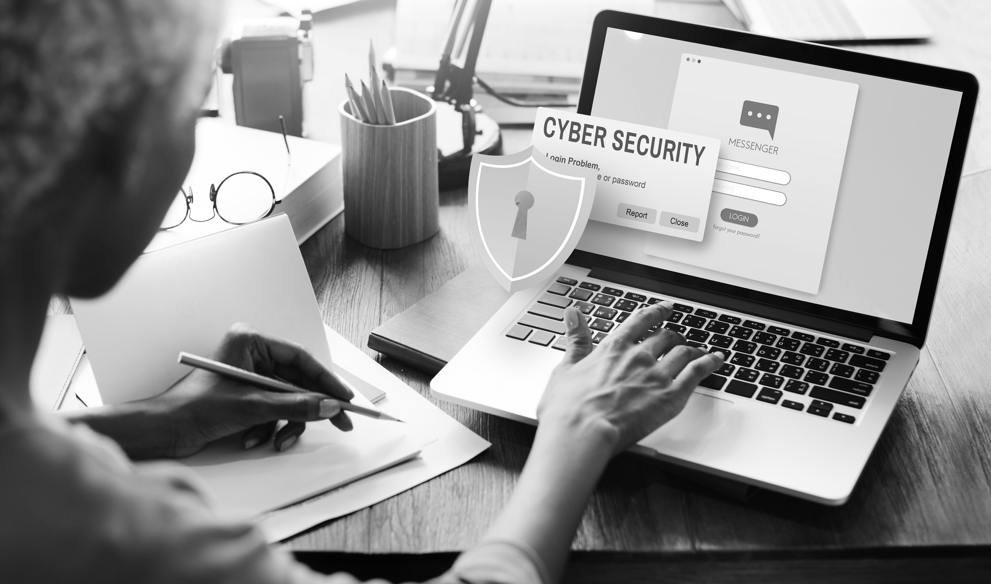

409344172 / Rawpixel.com / shutterstock.com

BSBXCS402

Promote workplace cyber security awareness & best practices

| Unit version | Document version | Release date | Comments/actions |
| --- | --- | --- | --- |
| BSBXCS402 | V1 | February 2022 |  |

Copyright

© TAFE Queensland 2021

Copyright protects this material. Except as permitted by the Copyright Act 1968 (Cth), reproduction by any means (photocopying, electronic, mechanical, recording or otherwise), making available online, electronic transmission or other publication of this material is prohibited without the prior written permission of TAFE Queensland.

Inquiries must be addressed to the TAFE Queensland Copyright Officer, Office of the Chief Academic Officer, TAFE Queensland, PO Box 16100, CITY EAST QLD, 4002, or Email [TAFEQLDIP@tafe.qld.gov.au](mailto:TAFEQLDIP@tafe.qld.gov.au).

Disclaimer

Every effort has been made to provide accurate and complete information. However, TAFE Queensland assumes no responsibility for any direct, indirect, incidental, or consequential damages arising from the use of information in this document. Data and case study examples are intended to be fictional. Any resemblance to real persons or organisations is coincidental.

If you believe that information of any kind in this publication is an infringement of copyright, in material in which you either own copyright or are authorised to exercise the rights of a copyright owner, and then please advise us by contacting the TAFE Queensland Copyright Officer, Office of the Chief Academic Officer, TAFE Queensland, PO Box 16100, CITY EAST QLD, 4002, or Email [TAFEQLDIP@tafe.qld.gov.au](mailto:TAFEQLDIP@tafe.qld.gov.au).

# Introduction

This Learner Guide has been developed to support you as a resource for your study program. It contains key information relating to your studies including all the skills and knowledge required to achieve competence.

## What will I learn?

This unit describes the skills and knowledge required to promote cyber security in a work area. It applies to those working in a broad range of industries who as part of their job role support policies, procedures and practice within an organisation that promote cyber security.

No licensing, legislative or certification requirements apply to this unit at the time of publication.

## Where can I get more information?

For further information on your qualification, accredited course or Unit/s of Competency, please go to: <https://training.gov.au/Training/Details/BSBXCS402>

## TAFE Queensland student rules

TAFE Queensland student rules are designed to ensure that learners are aware of their rights as well as their responsibilities. All learners are encouraged to familiarise themselves with the TAFE Queensland student rules, specifically as they relate to progress of study and assessment guidelines. A full guide to student rules can be found at Student rules[1].

## Information to support your learning and assessment

There’s always someone to help you. Undertaking further study can bring both excitement and challenges. Our Student Services, Learning Support and Library staff can help you make the most of your time at TAFE.

## Callout panels

A number of panels have been designed to help guide you to important information and actions throughout this Learner Guide. The full choice of panels you are likely to encounter to support you in your studies are included below. NB: not all the panels will be used in every learner guide.

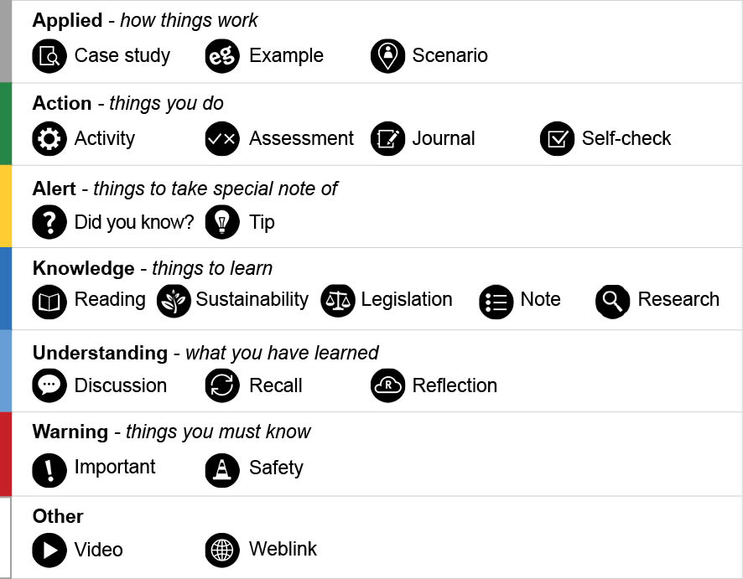

# Contents

Introduction 3

What will I learn? 3

Where can I get more information? 3

TAFE Queensland student rules 4

Information to support your learning and assessment 4

Callout panels 4

Contents 5

Welcome 9

Cyber Security – small to medium businesses 10

Introduction 10

The Australian Cyber Security Centre (ACSC) 11

Cyber threats key areas 12

Malicious software (malware) 13

Scam emails (phishing) 14

Ransomware 15

Software considerations - key areas 16

People and procedures - key areas 19

Employee training 22

Topic summary and review 24

Securing your business tools 26

Introduction 26

Software updates 27

Standalone devices 30

Turn on real-time protection 32

Emails and texts 34

Protecting staff from malicious messages 36

Mobiles and tablets 38

Private and public Wi-Fi 41

Protect the internet connection 42

Use a secure connection 45

Protecting accounts 47

cyber.gov.au resources 48

Topic summary and review 49

Getting a business back up and running 50

Introduction 50

ReportCyber 51

Protection of data – backup! 53

Workstations on the network 55

Backup solutions 56

Backup scheduling 57

Topic summary and review 61

Cyber security – large organisations 62

Introduction 62

cyber.gov.au - large organisations 63

Large organisations 64

Strategies to mitigate cyber security incidents 65

Critical infrastructure 67

Operational technology 68

Industrial control systems remote access protocol 69

Australian Government Information Security Manual (ISM) 70

Topic summary and review 71

Legislation, standards and policies 72

Introduction 72

Privacy Act 1988 73

Australian privacy principles 74

Notifiable data breaches 75

Information Privacy Act 2009 (QLD) 76

ISO 27001 77

National Institute of Standards and Technology (NIST) 78

International legislation 79

Topic summary and review 80

Company policies 81

Introduction 81

Privacy policy 82

Websites- cookies and third-party sites consent clauses 85

Email lists, registrations, and feedback 86

Topic summary and review 87

Data 88

Introduction 88

What is data? 89

Sensitive data 90

Personally identifiable information 91

Classifying data 93

Topic summary and review 94

Sending and receiving sensitive data 95

Introduction 95

The information life cycle 96

Privacy Impact Assessment (PIA) 98

Sending and receiving unsecured data 100

Sending and receiving secure data 102

Topic summary and review 104

File location 105

Introduction 105

Types of file locations 106

The Cloud 108

Topic summary and review 112

Data integrity and authorised access 113

Introduction 113

Attacks on data integrity 114

Mitigating data integrity attacks 116

Authorised personnel 117

Access permissions 118

Encryption 120

Encrypting files 121

Encrypting hard drive 123

Hashing 125

Hashing algorithms and files 126

Hashing messages 128

Topic summary and review 130

Destroying data 131

Introduction 131

Retention of data or records 132

Destruction of data – Queensland government agencies 133

Destruction of data – non-government organisations 135

Topic summary and review 136

Privacy Impact Assessment 137

Introduction 137

Undertaking a Privacy Impact Assessment 138

How to conduct a Privacy Impact Statement 139

Self-check answers 140

References 147

Appendix A – Privacy impact assessment 148

# Welcome

Welcome to the *BSBXCS402 – Promote workplace cyber security awareness and best practices* unit.

By completing this unit you will be able to:

* Develop cyber security awareness in work area
* Support effective cyber security practices in work area
* Review cyber security awareness in work area

# Cyber Security – small to medium businesses

## Introduction

Cyber security is not just a single thing but is made up of many components. These areas are:

|  |  |
| --- | --- |
| * malicious software (malware) | * backups |
| * scam emails (phishing) | * multi-factor authentication |
| * ransomware | * access control (logins and passwords) |
| * OS and software updates | * sensitive data |
| * training |  |

In this topic we will be providing information from the Australian Cyber Security Centre, to give you a greater understanding of cyber security threats, policies, and procedures.

### Objectives

By completing this topic, you will be able to do the following:

* Understand the advice and services the Australian Cyber Security Centre (ACSC) offer.
* Understand the key cyber threats that can lead to cybercrime.
* Know how to secure software.
* Identify the key areas of people and procedures.



1459422656 / Thitichaya Yajampa / shutterstock.com

## The Australian Cyber Security Centre (ACSC)

|  |
| --- |
| The Australian Cyber Security Centre provides trusted and relevant information on how Australia's small and medium businesses can protect themselves from the most common cyber security threats. *Copied under s113P –* [About small and medium businesses](https://www.cyber.gov.au/acsc/small-and-medium-businesses/about-this-section)*[2].* |

The majority of Australian businesses are small-to-medium. Those businesses employ more than 7 million people, so small businesses represent a significant contribution to Australia's wealth. Therefore, it is vital for these businesses to understand their cyber security risks, and to understand how to protect themselves, their customers, and their suppliers.

|  |  |
| --- | --- |
| DidYouKnow-01 | Did you know? |
| Although a cyber security incident can have a devastating impact on a small business, cyber security need not be difficult. There are simple measures that, if understood and implemented, can significantly avoid, or mitigate the impact of a cyber security incident affecting a small or medium business. | |

|  |  |
| --- | --- |
| Weblink-01 | Weblink |
| Check out the Australian Cyber Security Centre web site for the [latest ACSC cyber security advice, specifically tailored for small businesses.](https://www.cyber.gov.au/)[3] | |



1722273811 / mavo / shutterstock.com

## Cyber threats key areas

Even the smallest cyber security incident can impact heavily on a small business. The content in this section is designed to help you identify and explain the most common types of cyber threats and what you can do to protect a business.

|  |  |
| --- | --- |
| video | Video |
| Watch this video by TheUnlockr to help you understand more about [malware, the most common types, how they work & how to easily avoid them all.](https://www.youtube.com/embed/QozdEbyMK5E?rel=0)[4] | |

|  |  |
| --- | --- |
| Weblink-01 | Weblink |
| For more information view or download the Australian Government publication [Small Business, Cyber Security Guide[5]](https://www.cyber.gov.au/sites/default/files/2021-02/ACSC%20Small%20Business%20Cyber%20Security%20Guide.pdf) | |

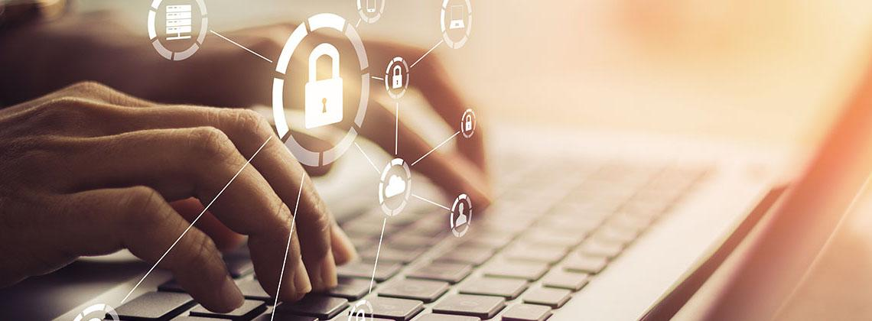

1097989835 / 13_Phunkod / shutterstock.com

## Malicious software (malware)

Malware is unauthorised software designed to cause harm.

Malware is a blanket term for malicious software including viruses, spyware, trojans and worms.

### Malware

|  |  |
| --- | --- |
| Why? | Disrupt. Damage. Deceive. Typically, for profit.  Malware gains access to important information such as bank or credit card numbers and passwords. It can also take control or spy on a user’s computer. |
| What? | What criminals do with this access and data includes:   * Theft * Pranks * Activism * Espionage * Other serious crimes |
| Who? | Anyone, anywhere. Malware creators can be anywhere in the world. They just need a computer, technical skills, and malicious intent. Criminals can easily access cheap tools to use malware against you. It is not personal. They are not targeting you specifically. It is just business. |

|  |  |
| --- | --- |
| **Important-01** | Important |
| **Protecting against malware**   * Automatically update your operating system. * Automatically update your software applications. * Regularly back up your business' data. | |

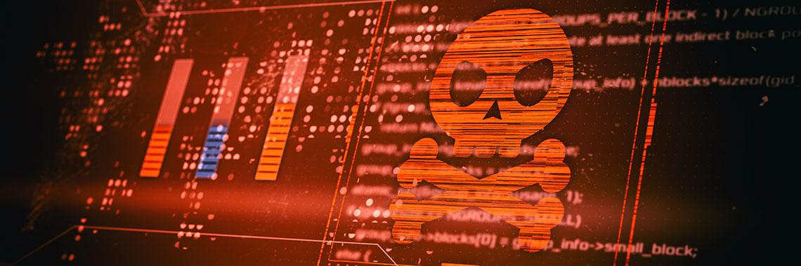

1804527658 / lucadp / shutterstock.com

## Scam emails (phishing)

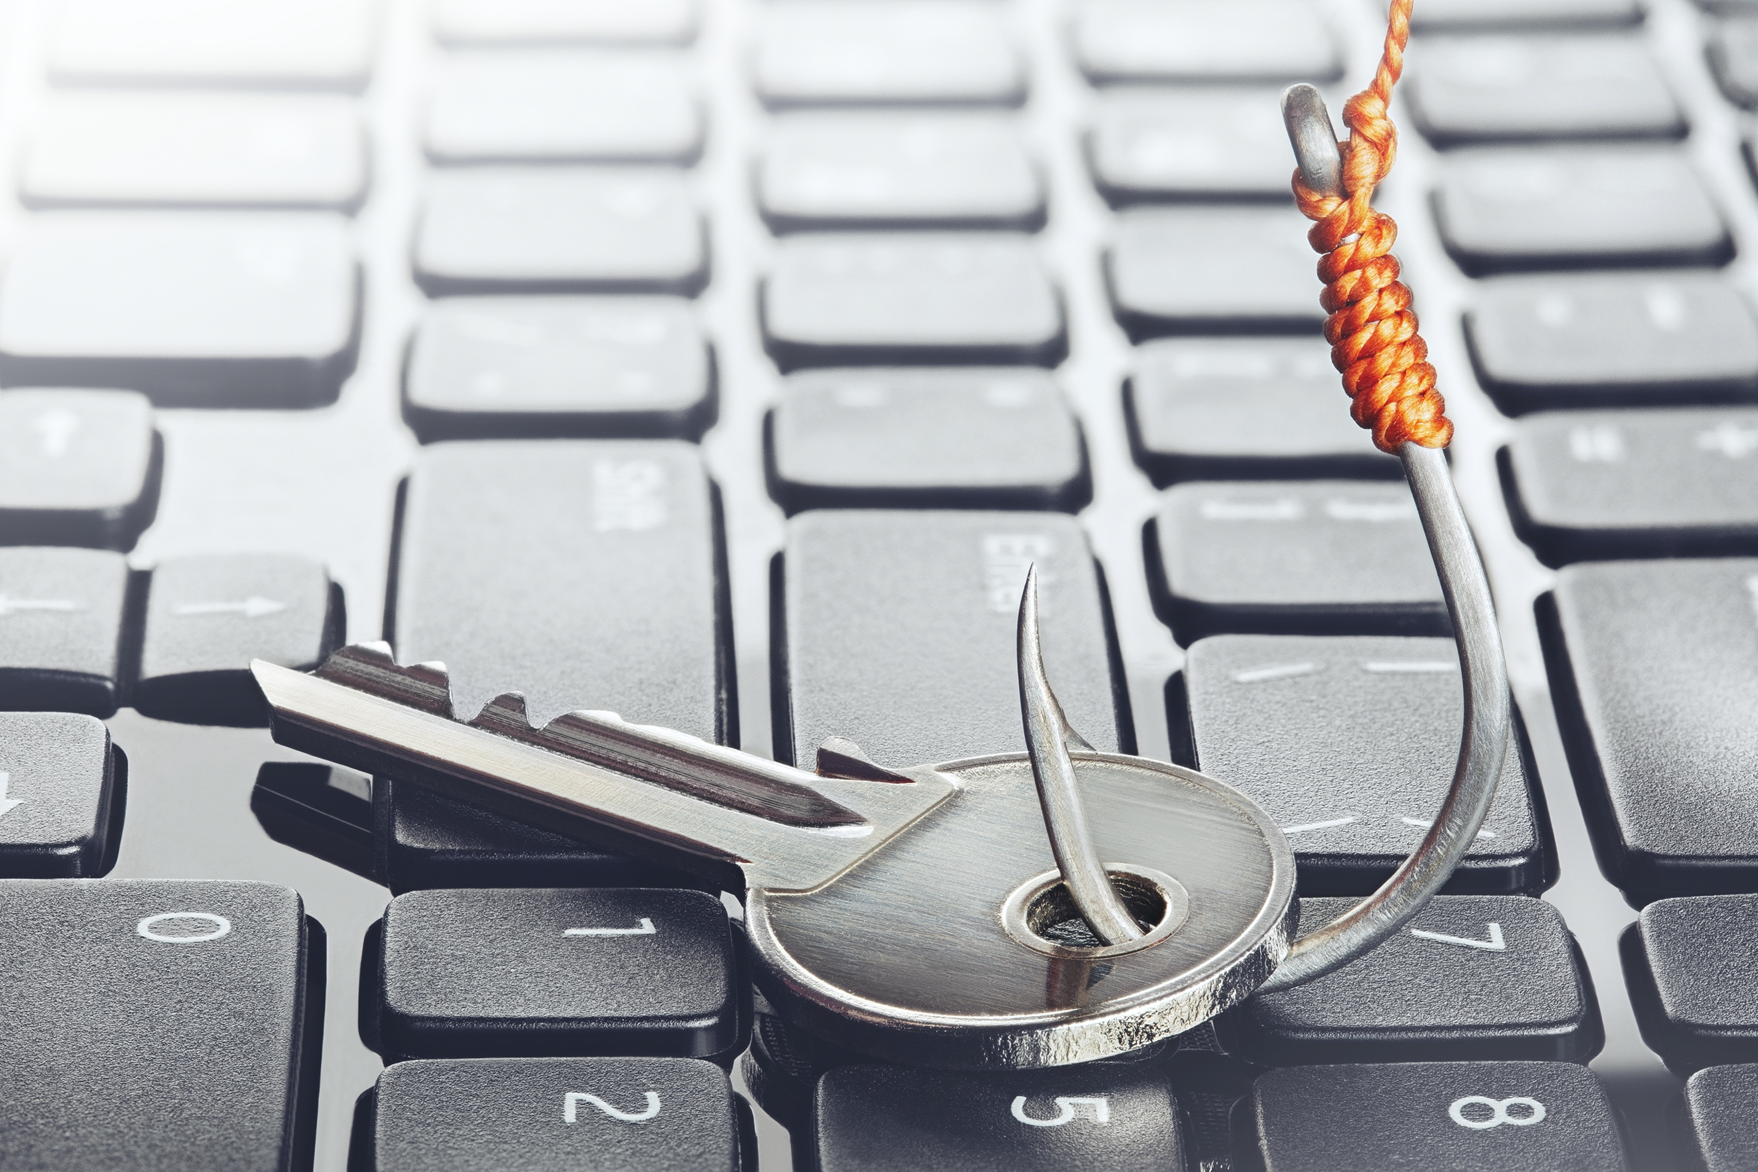

1860403078 / evkaz / shutterstock.com

Pronounced 'fishing', this describes 'dodgy' emails designed to trick recipients out of money and data, emails from individuals or organisations you 'think' you know. They mimic phrasing, branding and logos to appear 'real', before conning users to click on a link or attachment.

They defraud users by asking them to provide or confirm personal information, such as passwords and credit card numbers, or to pay a fake account. Phishing emails can also send an attachment, designed to look genuine, with malware inside.

### Phishing

|  |  |
| --- | --- |
| Why? | Money – it is a numbers game. Phishing emails are typically sent to thousands of people. Even if only a small percentage of recipients fall for the scam, they can net significant data and sums of money. |
| How? | * Phishing (low sophistication, many targets) Usually general emails with obvious warning signs, sent to thousands of targets * Spear Phishing (high sophistication, less targets) Fraudulent and sophisticated messages sent to a specific individual, usually the business owner, receptionist or finance and payroll manager * Whaling (high sophistication, less and high value targets) Spear phishing aimed at very big fish like CEOs |
| Where? | Emails, SMS, Instant Messaging, Social Media. Phishing scams are not limited to emails. They are increasingly sophisticated and harder to spot. |

|  |  |
| --- | --- |
| Safety-01 | Safety |
| Be cautious of:   * requests for money, especially if urgent or overdue * bank account changes * attachments * requests to check or confirm login details. | |

## Ransomware

|  |  |
| --- | --- |
| **Important-01** | Important |
| **Never pay a ransom** because paying it will not guarantee that you regain access and you may be vulnerable to a second attack. | |

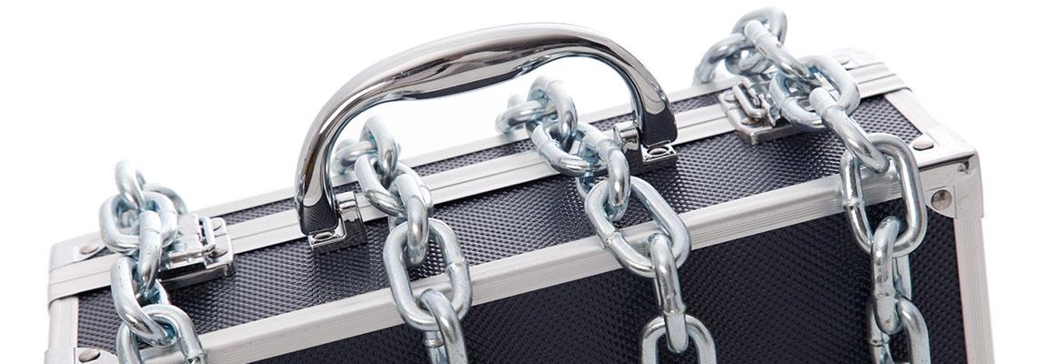

46125310 / Helda Almeida / shutterstock.com

Ransomware describes certain malware that locks down your computer and files until a ransom is paid.

Ransomware attacks are typically carried out via a malicious but legitimate looking email link or attachment.

When downloaded or opened, most ransomware encrypts a user's files, then demands a ransom to restore access – typically payable using cryptocurrency, like Bitcoin.

### Ransomware

|  |  |
| --- | --- |
| Why? | Money. Ransom, an age-old and effective crime, is now being committed online. Ransomware offers cyber criminals a low-risk, high-reward income. It is easy to develop and distribute. Also in cyber criminals’ favour, most small businesses are unprepared to deal with ransomware attacks. |
| Who? | Small, medium, and large businesses. Many small businesses are often less security conscious, are less likely to implement cyber security measures, and spend less on cyber security measures. |

|  |  |
| --- | --- |
| **Important-01** | Important |
| **Prevent and recover from ransomware**  Update operating systems.  Update software.  Backup your business. | |

## Software considerations - key areas

Securely organising software can significantly strengthen protection from the most common types of cyber threats.



414687593 / nentus / stock.adobe.com

The most important piece of software on a computer is the operating system because it manages the computer's hardware and all the programs. Therefore the operating system must be updated, backed up and maintained.

Learn more about improving software considerations in terms of strengthening resilience and maintaining currency and security.

### Automatic updates

|  |  |
| --- | --- |
| **Software updates.**  An update is a new, improved, or safer version of a software (program, app or operating system like Microsoft Windows or Apple iOS) your business has installed on its computers or mobile devices.  An automatic update is a default or 'set and forget' system that updates the software as soon as one is available. | |
| Why?  Safer. Faster. Better.   * Better online security * Improved protection (in real-time, directly by the experts) from loss of money, data, and identity * Enhanced features and efficiencies for programs and apps | When?  Today & every day.   * Turn on or confirm auto-updates, especially for operating systems * Regularly check for and install updates ASAP if auto-updates are unavailable, especially for software * Install updates as soon as possible (if auto-updates unavailable) * Set a convenient time for auto-updates to avoid disruptions to business as usual * If Anti-Virus software is installed, ensure automatic updates are turned on |

|  |  |
| --- | --- |
| Note-01 | Note |
| If hardware or software is too old it may not auto-update and leave a business susceptible to technical, software and security issues. The ACSC recommends upgrading all devices or software. Microsoft Windows 7 and Microsoft Office 10 was unsupported after 14 January 2020 and 13 October 2020 respectively. | |

### Automatic backups

**Data backups.**

|  |  |
| --- | --- |
| **What?**  A backup is a digital copy of a business' most important information e.g., customer details, sales figures. This can be to an external, disconnected hard drive e.g., USB or to the Cloud.  An automatic backup is a default or 'set and forget' system that backs up the data automatically, without human intervention.  Safely disconnecting and removing the backup storage device after each backup will ensure it is also not impacted during a cyber incident. | |
| Why?  Safer and faster.   * Quicker and easier to get the business back up and running if information is lost, stolen, or destroyed * Protects credibility of the business and help meets legal obligations. Certain industries have obligations to keep records for specific periods of time. Make sure you are aware of the business' data retention requirements. * Peace of mind that the business is always protected. | When?  Today and every day.   * Choose a backup system that's right for the business * Test that you are able to restore the backup regularly * Store a physical backup somewhere safe offsite, or in a fireproof rated safe onsite. |

### Multi-factor authentication

|  |  |
| --- | --- |
| What?  A security measure that requires two or more proofs of identity to grant a user access.  Multi-factor authentication (MFA) typically requires a combination of a pin code or a secret answer, a card or token, physically or something unique to them (e.g. fingerprint). | |
| Why?  Significantly more powerful security.  The multiple layers make it much harder for criminals to attack a business. Criminals might manage to steal one proof of identity e.g., PIN, but they still need to obtain and use the other proofs of identity. Two-factor authentication (2FA) is the most common type of MFA. | Where?  Accessing important internal and external accounts.  Small businesses should implement MFA wherever possible. Some MFA options include, but are not limited to:   * Physical token * Random pin * Biometrics/ fingerprint * Authenticator app * Email * SMS |

## People and procedures - key areas

|  |  |
| --- | --- |
| Note-01 | Note |
| Businesses, no matter how small, need to be aware of and consciously apply cyber security measures at every level. | |

Given that small businesses often lack the resources for dedicated IT staff, this section addresses how you can manage who can access, and who can control your business' information, and the training of your staff.

A businesses internal processes and their workforce are the last, and one of the most important lines of defence in protecting their business from cyber security threats.

Learn more about access control:

|  |  |
| --- | --- |
| What is access control?  Access control regulates who can access what within a business' computing environment. | It is a way to limit access to a computing system, allowing business owners to:   * decide who they would like to give access privileges to * determine which roles require what access * enforce staff access control limits. |
| Why control access?  To minimise risk of unauthorised access to important information.  Many small businesses employ internal staff or outsource work to external suppliers e.g., website hosting companies. | Access control systems help to protect a business by allowing administrators to limit staff and supplier access to the computer infrastructure:   * networks * files * applications * sensitive data. |
| Who to restrict?  Depending on the nature of a business, **the principle of least privilege** is the safest approach for most small businesses. It gives users the bare minimum permissions they need to perform their work. This also reduces the risk of an 'insider' accidentally or maliciously endangering a business. | Protecting against malware:   * restrict administrator privileges * do not share passphrases * remember to revoke accounts. |

|  |  |
| --- | --- |
| Safety-01 | Safety |
| **Passphrase** : Use a phrase or sentence, not one word, as a password. | |

Learn more about passphrases:

|  |  |
| --- | --- |
| What is a passphrase?  A passphrase is similar to a password. It is used to verify access to a computer system, program, or service. | Passphrases are most effective when they are:   * Used with multi-factor authentication * Unique – not a famous phrase or lyric, and not re-used * Longer – phrases are generally longer than words * Complex – naturally occurring in a sentence with uppercase, symbols and punctuation * Easy to remember – saves you being locked out. |
| Why use a passphrase?  Brute Force Attacks and Dictionary Attacks both generate millions of password/passphrase attempts per second. | * Greater security and more convenience. * Harder to crack against common password attacks * Easier to remember than random characters * Meets password requirements easily – upper and lower-case lettering, symbols, and punctuation |
| Where to use a passphrase | For all fixed and mobile devices.  Passphrases will significantly increase security across all of your business' devices. |

Table 1: A comparison of password vs passphrase security.

|  |  |  |  |  |
| --- | --- | --- | --- | --- |
| PASSWORD/ PASSPHRASE | TIME TO CRACK | | EASY TO REMEMBER | COMMENTS |
| Brute Force Attack | Dictionary Attack |
| password123 | Instantly Less than AU$0.01 | Instantly Less than AU$0.01 | Very Easy (too easy) | One of the most commonly used passwords on the planet. |
| Spaghetti95! | 48 hours AU$587.50 | Less than half an hour AU$6.10 | Easy | Some complexity in the most common areas, and very short length. Easy to remember, but easy to crack |
| 5paghetti!95 | 24 hours AU$293.70 | Less than 1 hour AU$12.20 | Somewhat Easy | Not much more complexity than above with character substitution, and still short length. Easy to remember, but easy to crack. |
| A&d8J+1! | 2.5 hours AU$30.60 | 2.5 hours AU$30.60 | Very Difficult | Mildly complex, but shorter than the above passwords. Hard to remember, easy to crack (against BFA). |
| I don't like pineapple on my pizza! | More than 1 Year More than AU$107,222.40 | More than 40 days More than AU$11,750.40 | Easy | Excellent character length (35 characters). Complexity is naturally high given the apostrophe, exclamation mark and use of spaces. Very easy to remember, and very difficult to crack. |

## Employee training

Employee training helps to protect the staff and business against cyber threats.

A cyber security incident response plan can help to change the habits and behaviours of staff and create a sense of shared accountability in keeping a small business safe.

### Cyber Plan

A cyber security incident response plan teaches how to:

* recognise
* avoid
* report
* remove
* recover.



1769714384 / XartProduction / shutterstock.com

Learn more about cyber security training:

|  |  |
| --- | --- |
| Business owners have a legal responsibility to keep your business and customer information safe. Employees can be the first and last line of defence against cyber threats Employees make mistakes, so having a cyber security training program is vital. |  |
| Cyber security is continuously evolving. Regular cyber security awareness and training keeps everybody up to date. This could be the difference between whether or not a criminal accesses the businesses' money or data. |  |
| Quick wins   * Incorporate, update, and regularly repeat. * Create a cyber security incident response plan. * Reward employees who find threats. * Create a cyber security culture. |  |

533928487 / SFIO CRACHO, 761152645 / NDAB Creativity,  
425235997 / G-Stock Studio / shutterstock.com

## Topic summary and review

This topic covered the knowledge and skills needed to understand the advice and services the Australian Cyber Security Centre (ACSC) offer, what key cyber threats that can lead to cybercrime, the knowledge to secure software, and the knowledge of key areas of people and procedures.

### Software considerations

* Turn on automatic updates for your operating system.
* Turn on automatic updates for your software applications.

Set up a convenient time for these to occur.

* Back up your business. Keep backups separated and unconnected from your devices, and regularly ensure you can restore your backups.
* Enable Multi-Factor Authentication wherever possible.

### People and procedures

* Establish an Access Control System to determine 'who' should have access to 'what'.
* Restrict administrator privileges to an 'as-required' basis.
* Do not share passphrases e.g., individual logins.
* Remember to revoke accounts when employees leave the business.
* Use strong passphrases that are:
* Use with Multi-factor authentication.
* Incorporate, update, and regularly repeat cyber security training and awareness amongst your employees.
* Create a cyber security incident response plan.
* Reward employees who find threats.
* Create a cyber security culture and encourage regular discussions.
* Always be cautious of emails that contain: requests for money, especially if urgent or overdue
* bank account changes
* attachments, especially from unknown or suspicious email addresses
* requests to check or confirm login details.

|  |  |
| --- | --- |
| SelfCheck-01 | Self-check – Cyber security for business |
| For most people the passphrase "5paghetti!95" is ?  *Choose the correct response.*   * Easy to remember * Somewhat easy to remember * Very difficult to remember   Which of the following reasons is why you should do software updates?   * Allows better access from outside to network for any person * Enhanced features and efficiencies for programs and apps * Gives full administration to any user on the domain   ACSC is an acronym for the ? *Choose the correct response:*   * Australian Cyber Security Centre * Australasian Cyber Security Centre * Australian Cyber Security Community   *Check your answers at the end of this Learner Guide* | |

# Securing your business tools

## Introduction

Managing a business' phones or computers from a cyber-security viewpoint is as important as managing the business' finances or reputation.

Taking the time to secure the business' software and implement security practices such as using strong and unique passphrases can set a business up for success and reduce the likelihood of common cyber threats impacting your money, data, and reputation.

### Objectives

By completing this topic, it is expected you will learn the following:

* How to best secure a business against common cyber threats.
* How to keep your software updated.
* How to deal with threats from emails and texts.
* How to use real time protection.
* How to secure a mobile or tablet device.
* How to safely use wi-fi (private and public).
* How to use secure connections.
* How to protect accounts.
* How to understand cyber.gov.au resources.



1590824860 / Gorodenkoff / shutterstock.com

## Software updates

|  |  |
| --- | --- |
| Tip-01 | Tip |
| Many software providers release free updates for their products to correct security concerns and improve functionality. An automatic update is a default or 'set and forget' feature that updates your software as soon as an update is available. | |

An update is a new, improved, or safer version of a software. All your business devices, including your phone, tablet, computer or laptop, use software to run, including:

* operating systems like Windows, Android and macOS
* apps on the organisation phones
* anti-virus, browser, or word processors.



1129542374 / Alexander Supertramp / shutterstock.com

Learn more about updating software:

|  |  |
| --- | --- |
| Safer. Faster. Better. | Cybercriminals, malicious programs, and viruses can find weaknesses in software (called vulnerabilities) to access the device.  Installing regular updates fixes these vulnerabilities to improve your business's protection from loss of money, data, and identity.  Installing software updates as soon as they become available limits the amount of time cybercriminals have to find and use these weaknesses.  Updates also provide enhanced features and efficiencies for programs and apps. |
| Today and every day. | * Take the time to install software updates as soon as they become available. * Better still, turn on or confirm auto-updates. * Set a convenient time for auto-updates to avoid disruptions to business as usual. * Regularly check for and install updates ASAP if auto-updates are unavailable, especially for software. |
| Software updates | Common software to keep updated include:   * operating systems such as Windows, Mac OS, iOS, Android * antivirus and security software * browsers such as Chrome, Firefox, Internet Explorer, Edge, or Safari * web plugins such as Adobe Flash, Adobe Reader, Skype, Apple QuickTime, iTunes, Java, ActiveX * other types of applications such as Microsoft Office. |
| Domain networks | On domain networks such as administered by Microsoft Windows Server, it is best to have the software updates managed by a central administrator. All organisations using a Microsoft Windows desktop environment should have now migrated to Microsoft Windows 10 version. And with all Microsoft Windows desktop versions on a Microsoft Windows Server domain the easiest way to administer updates across the domain is to use the Windows Server Update Services, or WSUS. |
| WSUS | WSUS is a scalable system which allows the administrator to configure automatic updates, create computer groups for deployment, and automatically and manually approve and deploy feature updates. For more on WSUS, see the weblink below. |

|  |  |
| --- | --- |
| Weblink-01 | Weblink |
| For more information about WSUS, see [Deploy Windows 10 updates using Windows Server Update Services (WSUS)](https://docs.microsoft.com/en-us/windows/deployment/update/waas-manage-updates-wsus)[6] | |

|  |  |
| --- | --- |
| Tip-01 | Tip |
| When you purchase a new device, check for updates straight away as part of initial set up, ensuring you enable automatic updates. | |

|  |  |
| --- | --- |
| video | Video |
| Watch this video to help you understand more about how to [install and configuring WSUS server Windows Server 2019](https://www.youtube.com/embed/0QNRtXFw8v8?rel=0)[7]. | |

## Standalone devices

Standalone devices range from the obvious desktop computer, tablets, smart phones, through to the not so obvious items such as a continuous positive airway pressure (CPAP) machine for treating sleep apnea disorders, as some CPAP machines will have WI-FI installed and therefore need the internal software, called firmware, to be updated for security.

|  |  |
| --- | --- |
| Tip-01 | Tip |
| Administrators of standalone devices need to research the assets under their control to be aware of what software requires updating. | |

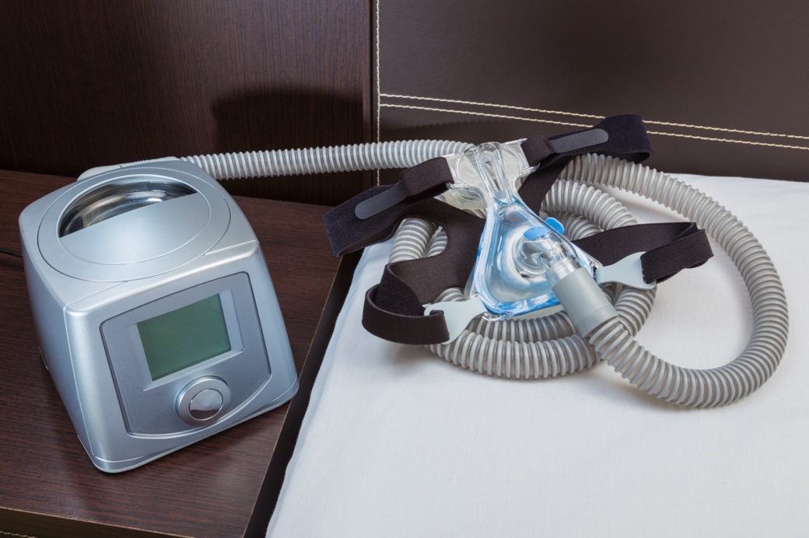

498364525 / Chalermpon Poungpeth / shutterstock.com

|  |  |
| --- | --- |
| Weblink-01 | Weblink |
| To find out more about standalone devices visit the following links:  [Updates for Android](https://www.cyber.gov.au/acsc/view-all-content/guidance/updates-android)[8]  [Updates for Apple](https://www.cyber.gov.au/acsc/view-all-content/guidance/updates-apple)[9]  [Turning on Automatic Updates – for iMac, MacBook, iPhone & iPad](https://www.cyber.gov.au/acsc/view-all-content/guidance/turning-automatic-updates-imac-macbook-iphone-ipad)[10]  [Updates for Windows (PC and Mobile)](https://www.cyber.gov.au/acsc/view-all-content/guidance/updates-windows-pc-and-mobile)[11]  [Turning on automatic updates – for Microsoft Windows 10](https://www.cyber.gov.au/acsc/view-all-content/guidance/turning-automatic-updates-microsoft-windows-10)[12] | |

|  |  |
| --- | --- |
| Weblink-01 | Weblink |
| View/download these guides:  [Step-by-Step Guide. Turning on Automatic Updates (For iMac & MacBook, and iPhone & iPad)](https://www.cyber.gov.au/sites/default/files/2020-11/Step%20by%20Step%20Guide%20-%20Turning%20on%20automatic%20updates%20for%20Mac.pdf)[13]  [Step-by-Step Guide. Turning on Automatic Updates (For Windows 10 and Windows 8 & 8.1)](https://www.cyber.gov.au/sites/default/files/2021-05/Step%20by%20Step%20Guide%20-%20Turning%20on%20automatic%20updates%20for%20Windows%20-%2020210321.pdf)[14] | |

## Turn on real-time protection

|  |  |
| --- | --- |
| Safety-01 | Safety |
| Prevention is better than a cure. By the time of your next antivirus scan, malware may have already made it on to your device and could have already caused damage. | |

Unlike an antivirus scan, which searches for malicious files or programs that are already on your device, real-time protection will detect and stop malware before it gets to your device.

|  |  |
| --- | --- |
| Tip-01 | Tip |
| **How do I turn on real time protection?**  Real-time protection should automatically turn itself on. However, it can be temporarily switched off, so it is important to check that the feature is up and running and is actively protecting your device. | |

* Real-time protection is one of the best cyber defences you can implement for your device and network. Real-time protection is one of the best cyber defences you can implement for your device and network.
* It compares any potential threats against a database of known malware such as viruses and Trojans and stops them in their tracks before they can cause harm. It compares any potential threats against a database of known malware such as viruses and Trojans and stops them in their tracks before they can cause harm.
* This database is only as knowledgeable as its last update. Make sure your device is updated regularly to increase your protection against newly created threats. This database is only as knowledgeable as its last update. Make sure your device is updated regularly to increase your protection against newly created threats.

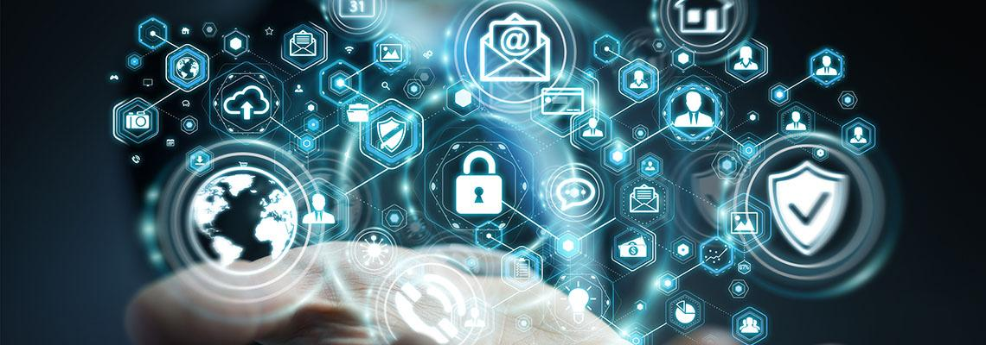

167897837 / sdecoret / stock.adobe.com

With a domain network, the administrator for the network should enforce control of the network. This control can be done in many ways:

1. Industry recognised end-point security suite, as this is the first and most vital step towards combating cybercrime. This type of security suite will also have components for spam, firewall, and VPN.
2. Group Policy not only controls the resources available to each user, but it also controls access to software and plug in devices, such as USB storage devices.
3. By disabling plug-in devices, you can eliminate one way of transmitting malware, especially for staff who have no reason to use USB plug-in devices.
4. Training is a component that is vastly underrated. Good staff training helps to get the message across about how dangerous to the organisation cybercrime is.
5. Communication and testing are a constant for any organisation. Keeping staff informed about the latest cybercrime threats and testing staff now and then with bogus emails is a good way of making sure staff are keeping aware.

|  |  |
| --- | --- |
| video | Video |
| Watch these two videos to help you understand more about Endpoint protection. [BSBXCS402 - Turn on Real Time Protection](https://www.youtube.com/embed/videoseries?list=PLr24-CFnxcCwRs4TSkbOykPZDNeG5lMJ8)[15]  *There are two videos in this playlist. Please use the playlist menu button in the top right corner to view all videos in this playlist.* | |

## Emails and texts



374936364 / Antonioguillem / stock.adobe.com

Email continues to be a popular medium for cybercriminals targeting people with scams, phishing, and malicious software (malware).

You need to know how to detect potentially suspicious messages and the steps you can take to protect yourself.

Cybercriminals use email to carry out a range of threats. To some degree these threats all work the same way and rely on exploiting the same human weaknesses.

Learn more about how to protect yourself when using email:

|  |  |
| --- | --- |
| Malicious links  A number of different threats use email for their success, including malware, phishing, and different types of scams. | These threats work as follows:   * You receive a message that contains an appeal or threat, and the message tries to convince you to do something. * You assess the characteristics of the message, decide the appeal is legitimate and take the requested action. * The action, which might be clicking a malicious link, opening a malicious file, or sending sensitive information like credit card details, results in a negative consequence for you as the receiver of the message and an illegitimate gain for the sender of the message. |
| Social engineering | Cybercriminals use a technique called 'social engineering' as a way of enticing and manipulating people. Social engineering makes it harder to spot malicious emails. They use tricks to lower your natural defences against deception, i.e. by pretending to be someone you trust, or by making a highly attractive offer.  Cybercriminals are putting more time, effort, and money towards researching targets to learn names, titles, responsibilities, and any personal information they can find. Afterwards, they usually call or send an email with a made up, but believable story designed to convince the person to give them certain information. |

|  |  |
| --- | --- |
| Spam | Electronic junk mail is known as spam. These are electronic messages, you may not have asked for, but are sent to your email account, mobile phone number, or instant messaging account.  The content of spam messages varies. Some messages promote legitimate products or services, while others attempt to trick you into following a link to a scam website where you will be asked to enter your bank account or credit card details. |
| Spam filters | The best way to protect yourself from the influence of malicious email is to stop it from reaching you.   * Don't share your email address online unless necessary. Consider setting up a separate email address to use for online forms or browsing. * When possible, do not allow staff to use personal email accounts over the network - business use only. * Use a spam filter to catch these messages before they get to your inbox. Most modern email systems have effective spam filters. * Delete spam messages without opening them. |
| Privacy policy  Note: Cybercriminals can be clever, and some messages might still make it through to your inbox.  See the next topic for more information on how to protect staff from malicious messages. | Other steps you can take to limit spam:   * Before using your email address online, read the website privacy policy – it will tell you how they will use the personal information you provide. * When you sign up for an online account or service, be aware of default options to receive additional emails about other products and services. |

## Protecting staff from malicious messages

### Protection from malicious messages:

* Do not open messages if you don’t know the sender, or if you’re not expecting them.
* Be suspicious of messages that aren’t addressed directly to the staff member, or don’t use the staff member’s correct name.
* Staff should not reply to, or forward chain letters received by email.
* Think carefully before clicking on links or opening attachments.
* If a message seems suspicious, contact the person or business separately to check if they have sent the message. Use contact details you find through a legitimate source and not those contained in the suspicious message.
* Before clicking on a link, hover over it to see the actual web address it links to (at the bottom of the browser window). If you do not recognise/ trust the address, search relevant key terms in a web browser to find the article, video, or webpage without directly clicking on the suspicious link.
* Ensure staff have up-to-date anti-virus software installed on any device used to access email.

|  |  |
| --- | --- |
| Tip-01 | Tip |
| All the above should be part of a training session for all staff to attend. Training is still one of the best ways to counter spam and cyber-attacks. | |

### Multi-factor authentication

**Protect your email accounts with multi-factor authentication**

Many web email service providers like Google, Microsoft and Yahoo provide multi-factor authentication (also known as two-factor authentication) for extra security of account data.

How does it work? Typically, it is a two-step process where a user must provide more than one type of proof that they are authorised before they can access an account. For example, you might need to provide a password as well as a second form of identification, like a code sent to a mobile phone that is registered with your account.

Multi-factor authentication makes it more difficult for someone else to sign into an email account. Even if someone finds your password, they would be stopped from getting into an account unless they have the second form of identity. This security feature is also available for other systems, for example, when banking online or accessing government services online such as myGov.

|  |  |
| --- | --- |
| Tip-01 | Tip |
| Where possible, we recommend you turn on multi-factor authentication for all accounts | |

### Email account security

**Check your email account security**

Email is a common target for cybercriminal activity. If someone gains unauthorised access to your email account, they can access your private communications. A cybercriminal could steal the business' sensitive information, or even commit fraud and send emails pretending to be from the organisation.

After any email security incident, there should be a review the security on all accounts, even if you are not sure which staff member have been hacked.

Reviewing account security will help you to identify intruders, regain control of the accounts, and help prevent cyber-attacks in the future.

|  |  |
| --- | --- |
| Weblink-01 | Weblink |
| These step-by-step guides explain how to check the security of your email account for Outlook.com, Microsoft 365, Live, Hotmail, MSN and Gmail on your desktop:  [Step-by-Step Guide. Check Email Account Security. Outlook, Microsoft 365, Live, Hotmail and MSN](https://www.cyber.gov.au/sites/default/files/2021-07/ACSC%20Step%20by%20Step%20Guide%20-%20Email%20Security%20Outlook.pdf)[16]  [Step-by-Step Guide. Check Email Account Security. Gmail](https://www.cyber.gov.au/sites/default/files/2021-07/ACSC%20Step%20by%20Step%20Guide%20-%20Email%20Security%20Gmail.pdf)[17] | |

## Mobiles and tablets

Today smartphones and tablets are used to connect, shop, work, bank, research, track our fitness and complete hundreds of other tasks any time, and from any location. And as such, organisations need to treat mobile phones like your wallets with cash in them.

What can happen if your mobile device is lost or stolen?

* It may be used to access accounts, sensitive information, or steal staff identity using information stored on the device.
* Lose irreplaceable data like photos, notes or messages (if it is not backed up).
* Social media accounts may be accessed, which can enable a cybercriminal to steal staff identity using the profile information (such as your date of birth and photo).
* A cybercriminal may use the phone/tablet or its SIM card to rack up telephone charges to the organisations’ account.
* You may have to cover the cost of a new device, while still paying off the lost or stolen one.



449932154 / Tierney / stock.adobe.com

|  |  |
| --- | --- |
| Secure mobiles or tablet devices  Some simple actions can help to secure the organisation's mobiles or tablet devices and keep them safe. | |
| Use the following advice to make mobile phones or tablets more secure:   * Set a password, Personal Identification Number (PIN), passcode, gesture or fingerprint that must be entered to unlock the device. Don't forget to put PINs on the SIM card and voicemail, and ensure the device is set to automatically lock. * Install reputable security software that includes antivirus and anti-theft/loss protection. Only install applications from the official device application store and do not 'jailbreak' your device. * Use the device's automatic update feature to install new application and operating system updates as soon as they are available. * Set the device to require a password before applications are installed. This will prevent unauthorised modifications to the device. Parental controls could also be used for this purpose. | * Leave Bluetooth turned off or in undiscoverable mode (hidden) when you are not using it. * Ensure your device does not automatically connect to new networks without your confirmation. * Record the International Mobile Equipment Identifier (IMEI) of the handsets. Your IMEI is a 15- or 17-digit number often printed on a label under the battery or found in the settings under general information about your device. If the device is lost or stolen, report this number to service provider and they can stop the handset from being used. * Enable the remote locking and/or wiping functions if your device supports them. |
| Secure information on mobile devices  The information stored on organisations' phones is valuable, take these steps to help protect it: | |
| * Back up your data regularly, either with a backup application or by manually syncing the device with the cloud, or a computer. * Do not save passwords or PINs as contacts on the phone or tablet. * Enable device encryption to protect data stored on the device where possible. | * Check the privacy permissions carefully when installing new apps on the device and only install apps from reputable vendors. Where you can, make apps or profiles private and password protected.  Learn more about protecting yourself from mobile malware. * Ensure you thoroughly remove data from the device before selling or recycling it. |

|  |  |
| --- | --- |
| Be mindful of where and how you use your mobile or tablet  Being mindful of where and how you use your device can help protect the organisations' data and the device. | |
| You also need to be careful about where you use the mobile device - both online and off:   * Use public Wi-Fi networks wisely – for example, do not do online banking or accessing sensitive data using these networks. Learn how to protect yourself when using public Wi-Fi. * Do not use chargers supplied by third parties or charge electronic devices at public charging stations or USB charging outlets. Only use genuine chargers supplied with electronic devices. * When connecting using Bluetooth, do it in private areas only. * Use reputable sites and applications when downloading anything from the internet. | * Log out of websites when you are finished. * Turn off location services when you are not using them and limit the applications that can track and use this information. * Think before you click. Do not open links or attachments unless you are expecting them, and you trust the source. If in doubt, hovering over links often allows you to see the destination URL and you can decide if you recognise * the website or email address – although URL shortening can make this difficult. |

|  |  |
| --- | --- |
| Weblink-01 | Weblink |
| Visit this link for advice from the Australian Cyber Security Centre about [Travelling with Electronic Devices.[18]](https://www.cyber.gov.au/acsc/view-all-content/publications/travelling-overseas-electronic-devices) | |

## Private and public Wi-Fi

It's easy for information sent using public Wi-Fi access to be intercepted, so you need to be careful about what information you send or receive while connected.

The organisations' internet connection is a way for you to interact with the outside world, but it also provides a channel into your computer. If your internet connection isn't secure someone may use it to steal sensitive or financial information for malicious purposes.

|  |  |
| --- | --- |
| Tip-01 | Tip |
| * Public Wi-Fi 'hotspots' in places like cafés, airports, hotels, and libraries are convenient, but they can be risky. * Avoid sending or receiving valuable or sensitive information when connected to public Wi-Fi networks. | |

|  |  |
| --- | --- |
| Safety-01 | Safety |
| Remember: If you don't take steps to protect your internet connection and network, they could be used illegally and without your knowledge. | |



273084574 / farizun amrod / stock.adobe.com

## Protect the internet connection

There are a number of easy things you can do to make the organisation's internet connection and network more secure.

Computer security professionals refer to these steps as 'hardening' measures and they do just that – they make your software, your devices, your network, and the connections between them harder to access and more resilient to attack.

Learn more about protecting the internet connection:

### Routers and modems



141616827 / Oleksandr Delyk / stock.adobe.com

Most homes will have a modem supplied by the ISP. This modem is also a router, WI-FI access point, and a network switch combined in the one box.

In most businesses the individual components may be separate boxes with greater functions than those found at home. A modem connects that network to the internet. Many internet providers offer a combined router/modem unit that performs both these functions in one device, and here we refer to the device simply as a router.

### Setting up your router

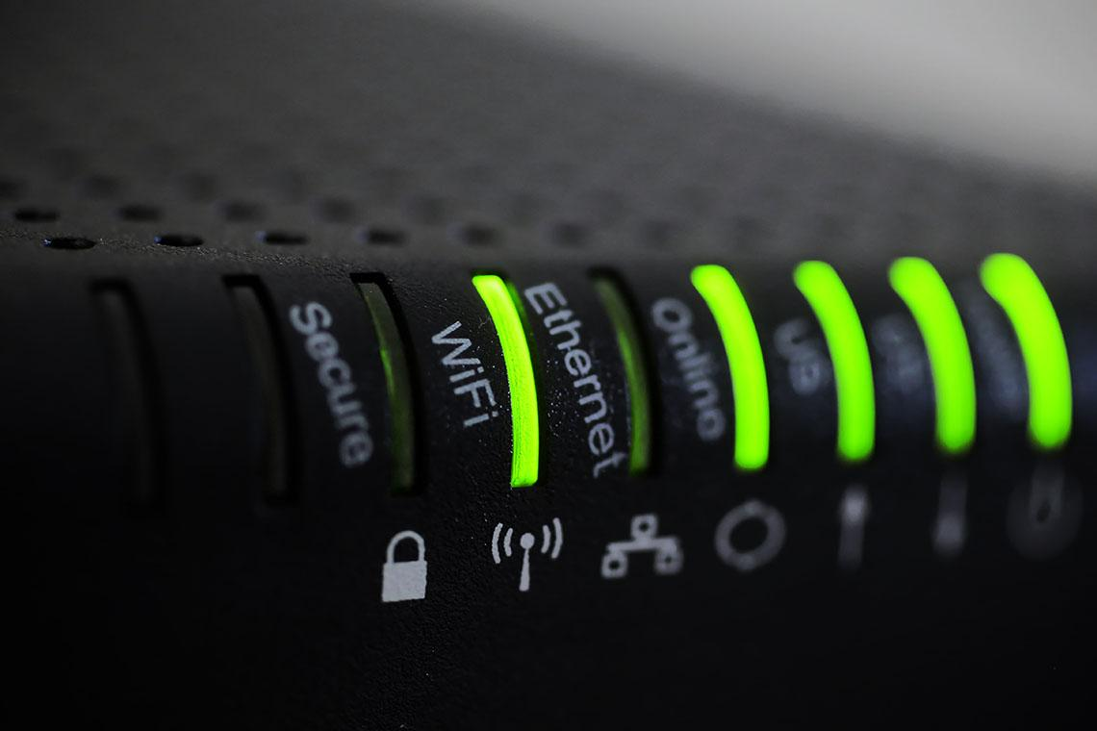

75210633 / tanvirshafi / stock.adobe.com

In many cases it is straightforward for a cybercriminal to determine the make and model of the device you are using, and then access your router.

Ensure the network password provided by the ISP or router manufacturer is hard to guess. If not change it - find out how to set strong passwords.

Some manufacturers' administrator passwords to router settings are publicly available online, so it's imperative you change the device password. Where possible, change the default administrator username (typically 'admin' or 'administrator') to something hard to guess.

Ensure remote management is disabled. Remote management on your modem or router allows you to make changes to your internet connection, including passwords, by remote login. Disabling this protects you from unauthorised access to your router.

Enabling the 'guest' feature on your network means you don't need to share your password with visitors. You can cycle the guest Wi-Fi password without having to reset the wireless devices in your house.

### Use the strongest encryption protocol

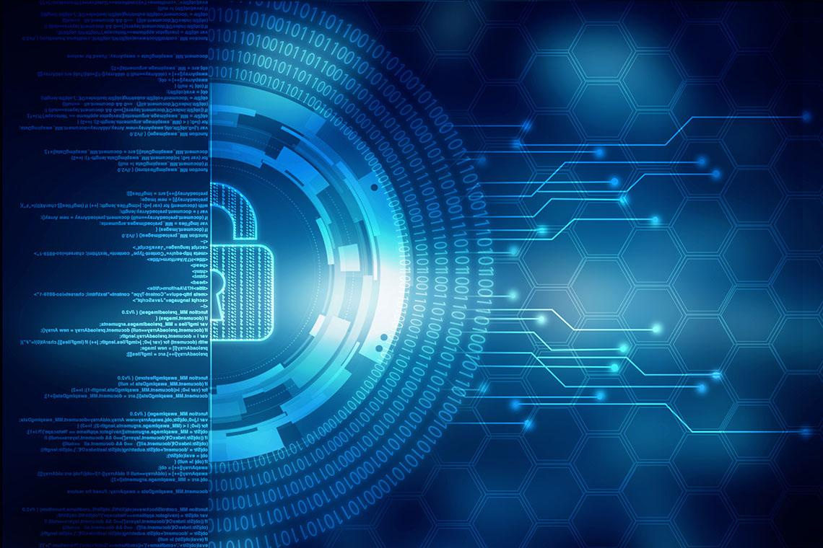

94905049 / jijomathai / stock.adobe.com

Wireless networks don't need a wire between computer and internet connection, so anyone within range can intercept an unprotected signal. So, you need to use the strongest encryption protocol provided by your router, currently a minimum of WPA2. Check in the device settings. The WPA2 protocol was introduced in 2006, so routers purchased on or before this will not have the option of selecting it.

Manufacturers often classify old devices as 'legacy' models and no longer develop firmware upgrades for them. This can leave you exposed to known security flaws. In that case, you should consider replacing your router.

### Make sure your router uses the latest 'firmware' available

Firmware is the software embedded into a router that determines the functions it can perform. Just like new software updates for your computer, new firmware for a router will provide improved features and address any security vulnerabilities.

To find out which version of firmware is installed on a router, some have a button you can click to automatically check for more recent versions. If not, log in to the device and check its settings. Go to the manufacturer's website to check if there's a recent version of firmware for your device and download it.



331473777 / Ilona / stock.adobe.com

Be careful when you do this. Make sure you follow the instructions in your device's manual and select the correct firmware upgrade version for your model of router, because a failed update can render your device unusable and disconnect all your computing devices from the internet.

|  |  |
| --- | --- |
| Tip-01 | Tip |
| Upgrading to a current router model will offer significant benefits such as additional features and configuration options, and most importantly, faster data transfer speeds. | |

|  |  |
| --- | --- |
| Safety-01 | Safety |
| Not using the strongest encryption protocol increases the chances of your internet communications being intercepted by cybercriminals. | |

## Use a secure connection

Wherever they can, staff should avoid using hotspots that are run by people or organisations they don't know or trust.

Criminals have been known to set up Wi-Fi hotspots in order to steal users' banking credentials, account passwords, and other valuable information.

|  |  |
| --- | --- |
| * Confirm the 'official' hotspot name from venue staff and manually connect the device to it. Do not let the device automatically connect to the first hotspot in its list. * Turn off network discovery options like "Remember networks this device has joined." * Turn off file sharing. If staff have file sharing turned on and they connect to a public Wi-Fi hotspot, the device files could be accessed by others using the same hotspot. | * Install a reputable virtual private network (VPN) solution on organisation's devices. When enabled and configured correctly, a VPN is a service that uses encryption to keep information secure when using public Wi-Fi, as well as providing a level of anonymity. * That said, a VPN doesn't secure the devices or online accounts, so it's important that the device is still kept up to date with the latest security software updates, and always use strong passwords. |

Consider the following when selecting a VPN service provider:

* Look at independent reviews online. You will often find honest reviews from other users, so research the app on reputable blogs, websites or trusted sources that are not the app’s own website. Also find out more about the app’s description, its content rating, and the developer, and whether an app only encrypts some of your data, not all of it.
* Note where the company is based. Make sure to select an VPN provider that is based in a country with strong privacy laws. This reduces the possibility that data collected by your VPN will be shared with others.
* VPN apps may provide personal information to third parties. Many VPN apps are funded by advertising (which appears within the app) giving consumers the option to download the apps for free. In exchange, VPN apps may share information with third parties. If use a VPN app to keep your internet activity private, make sure to review its terms and conditions and privacy policy, to see if it shares information with third parties.
* Consider the app permissions. Apps will ask for access to certain information on the device to help improve how it operates for you. For example, the app may request permission to read your text messages or access your photos. These permissions will be outlined and explained on the app store or during installation. Generally, a VPN application should not require access to your personal data.

|  |  |
| --- | --- |
| Tip-01 | Tip |
| Do not do your online banking or shopping, send confidential emails, or enter passwords or credit card details on public Wi-Fi. Wait until you are using a secure home, office of mobile connection. Do not do your online banking or shopping, send confidential emails, or enter passwords or credit card details on public Wi-Fi. Wait until you are using a secure home, office of mobile connection.  When accessing websites while on public Wi-Fi, make sure the websites are secure. Always look for a https ('s' stands for secure) in the website address and a padlock on the web browser. When accessing websites while on public Wi-Fi, make sure the websites are secure. Always look for a https ('s' stands for secure) in the website address and a padlock on the web browser.  *Always remember to disconnect from the hotspot after you have finishing using it. But remember, no public Wi-Fi is 100% secure, so consider using your own mobile data for any sensitive transactions.* Always remember to disconnect from the hotspot after you have finishing using it. But remember, no public Wi-Fi is 100% secure, so consider using your own mobile data for any sensitive transactions. | |

|  |  |
| --- | --- |
| Safety-01 | Safety |
| **Precautions to secure your devices**  When accessing the internet at a public Wi-Fi location, staff should take extra precautions.   * Ensure the phone, tablet or laptop has a reputable anti-virus installed. * Keep software patched and up to date with the latest release version, to ensure that any identified security holes have been closed. * Set up two-factor or multi-factor authentication wherever possible. Online systems such as banks, Google Mail and Facebook offer this option for transactions or when logging into accounts.   This way, a malicious hacker can't log in without also having access to your phone or SMS inbox, even if they know your username and its associated password. | |

## Protecting accounts

Users with *administrator accounts* have access to full control of a computer, so cyber-criminals will especially target that account level to gain control of a computer. For 'every day' use, avoid using an administrator account, as doing so will restrict a virus' access if the computer becomes infected.

|  |  |
| --- | --- |
| Weblink-01 | Weblink |
| View/download the following resources for more information and guidance about managing user accounts:  [Step-by-Step Guide. Managing user accounts for Microsoft Windows 10](https://www.cyber.gov.au/sites/default/files/2021-07/Step%20by%20Step%20Guide%20-%20Managing%20user%20accounts_Windows%2010.pdf)[19]  [Step-by-Step Guide. Managing user accounts for macOS](https://www.cyber.gov.au/sites/default/files/2021-05/Step-by-Step%20Guide%20-%20Managing%20user%20accounts%20for%20macOS%20-%2020201126.pdf)[20] | |

|  |  |
| --- | --- |
| video | Video |
| Watch this video to help you understand more about [creating OU, users and groups on the Active Directory 2019.[21]](https://www.youtube.com/embed/cETbT22TWEE?rel=0) | |

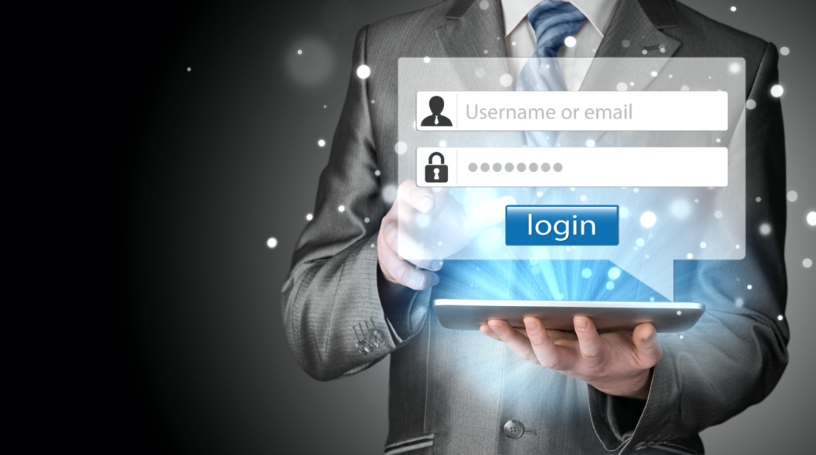

275346704 / Nata-Lia / shutterstock.com

## cyber.gov.au resources

Over time the differing administrations of the Australian Commonwealth government has recognised more and more the effects of cybercrime in Australia and from outside forces. It has now got to the extent that foreign governments are using cybercrime as a new battlefield, hence the term cyberwar.

|  |  |
| --- | --- |
| Weblink-01 | Weblink |
| The Australian Commonwealth government has provided the following online resources, divided into four categories:  [Individuals & families](https://www.cyber.gov.au/acsc/individuals-and-families)[22]  [Small & medium businesses](https://www.cyber.gov.au/acsc/small-and-medium-businesses)[23]  [Large organisations & infrastructure](https://www.cyber.gov.au/acsc/large-organisations-and-infrastructure)[24]  [Government](https://www.cyber.gov.au/acsc/government)[25] | |

*The resources in this guide so far are in the category of small and medium businesses.* However, you should also be aware of the information on *large organisations and infrastructure* as it is more in depth for ICT equipment and security.

|  |  |
| --- | --- |
| Weblink-01 | Weblink |
| See the following small and medium business resources:  [Know how to spot phishing (scam) messages](https://www.cyber.gov.au/acsc/view-all-content/campaign/know-how-spot-phishing-scam-messages)[26]  [Step-by-step guides](https://www.cyber.gov.au/acsc/small-and-medium-businesses/step-by-step-guides)[27]  [Small Business Cyber Security Guide](https://www.cyber.gov.au/sites/default/files/2021-02/ACSC%20Small%20Business%20Cyber%20Security%20Guide.pdf)[28] | |

## Topic summary and review

This topic covered the knowledge and skills needed to best secure a business against common cyber threats, keep your software updated, recognise threats from emails and texts, and understand real time protection.

The topic also looked at how to secure a mobile or tablet device, how to use secure connections, how to protect accounts and explained private and public Wi-Fi.

The last part of the topic gave you an understanding of the cyber.gov.au resources.

|  |  |
| --- | --- |
| SelfCheck-01 | Self-check – Securing business tools |
| One of the precautions when accessing the internet at a public Wi-Fi location, is to  ?  *Choose the correct response:*   * Disable the firewall to allow easier access * Make sure no one can see your screen * Ensure the phone, tablet or laptop has a reputable anti-virus installed   One way for staff to protect themselves from malicious emails, is that the staff should not ?  *Choose correct response:*   * be suspicious of messages that aren’t addressed directly to the staff member * think carefully before clicking on links or opening attachments * open messages if you don’t know the sender   WSUS is an acronym for? Choose the correct response:   * Windows System Update Services * Windows Server Update Services * Wally Smith Uber Service   *Check your answers at the end of this Learner Guide* | |

# Getting a business back up and running

## Introduction

As with any incidents with cybercrime or data breach there are a number of steps you can take to get the business back up and running.

So that authorities can track or help with cybercrime, an incident needs to be reported.

The Australian Cyber Security Centre have set up a number of procedures and guidance for all businesses, big and small.

### Objectives

In this section you will learn to:

* Understand Australian Cyber Security Centre's resources.
* What the ReportCyber process is.
* Protection of data using backups.



436634006 / muse studio / stock.adobe.com

## ReportCyber

|  |  |
| --- | --- |
| Tip-01 | Tip |
| ReportCyber is the Australian Commonwealth government reporting system for victims of cybercrime. | |

"Cybercrime is the use of a computer or online network to commit crimes such as fraud, online image abuse, identity theft or threats and intimidation. As cybercrime becomes more sophisticated, criminals are targeting individuals, businesses, education institutes and governments".© Commonwealth of Australia 2020. Australian Cyber Security Centre, 11/01/21. CC BY 4.0

|  |  |
| --- | --- |
| Weblink-01 | Weblink |
| For more information visit [ReportCyber](https://www.cyber.gov.au/acsc/report) [29], which has replaced ACORN as the tool to report cybercrime. This site provides detailed information about when you **should** or **should not** use ReportCyber and also what will happen **after you have reported**. | |

### What can I report to police through ReportCyber?

Some common types of cybercrime include:

* **Identity theft and fraud**  
  Identity theft is when a cybercriminal gains access to your personal information to steal money or gain other benefits. They can create fake identity documents in your name, get loans and benefits or apply for real identity documents in your name, but with another person's photograph.
* **Online fraud**  
  You have been deceived into sending money or goods to someone online, also known as shopping fraud, romance fraud or investment fraud.
* **Cyber-enabled abuse**  
  Someone is bullying, harassing, or stalking you online. This can take the form of constantly messaging, emailing, or texting you in a way that makes you feel intimidated or scared, impersonating you or spreading rumours about you, checking your email, or tracking your internet use.
* **Online image abuse**  
  Image-based abuse happens when an intimate image or video is shared without the consent of the person pictured. This includes images or videos that have been digitally altered (using Photoshop or specialised software). Image-based abuse is sometimes called other things like 'revenge porn', ' intimate image abuse' or 'image-based sexual abuse'.
* **Affected devices**  
  Malware (short for 'malicious software') is software that cybercriminals use to harm your computer system or network. Cybercriminals can use malware to gain access to your computer without you knowing, in targeted or broad-based attacks.



191488939 / kras99 / stock.adobe.com

## Protection of data – backup!

|  |  |
| --- | --- |
| Tip-01 | Tip |
| Regularly backup the data on your network, personal computer, phone, or tablet to the cloud or to external hard drives. This will protect you from data loss, hardware failures, breakage, theft, or malware infection like ransomware. | |

Backing up and restoring your files speeds up the process of getting up and running again after a threat event. Every organisation should have strategies and procedural policies in place for the backing up of critical data.

Depending on the size of the organisation it maybe just a simple backup of a standalone workstation or network attached storage device, though to a server backup. As a budding entry level IT support member, we will concentrate on how to backup for micro to small business organisations.

|  |  |
| --- | --- |
| Weblink-01 | Weblink |
| To learn more about baking up and restoring files, view/download this [step-by-step guide](https://www.cyber.gov.au/sites/default/files/2020-09/Step-by-Step%20Guide%20-%20Backing%20Up%20and%20Restoring%20Your%20Files%20%28For%20PC%29.pdf) [30] from ACSC. | |

The following table gives you an idea of the types of backups available at present:

|  |  |  |
| --- | --- | --- |
| Data Size | No NBN service | Reliable NBN service |
| Up to 4GB | Rewriteable DVD  USB memory stick | Synchronised data folders with cloud services |
| 10GB to 30GB | USB memory stick  USB portable HDD | Synchronised data folders with cloud services  Data sitting in the cloud |
| 30GB to 2TB | USB portable HDD  LTO Ultrium Tape Drive | Synchronised data folders with cloud services  Data sitting in the cloud |

|  |  |
| --- | --- |
| Note-01 | Note |
| **Cloud storage**  With the advent of NBN across the major population areas of Australia, cloud storage is becoming more prevalent. This is helped by vendors such as Microsoft and Amazon setting up multiple data centres in Australia, therefore meeting Australian privacy concern for medical and financial data. | |

|  |  |
| --- | --- |
| Weblink-01 | Weblink |
| Learn more about the [Amazon AWS](https://aws.amazon.com/about-aws/global-infrastructure/localzones/locations/?nc=sn&loc=3)[31] and the [Microsoft Azure](https://azure.microsoft.com/en-au/global-infrastructure/geographies/) [32] regional data centres. | |

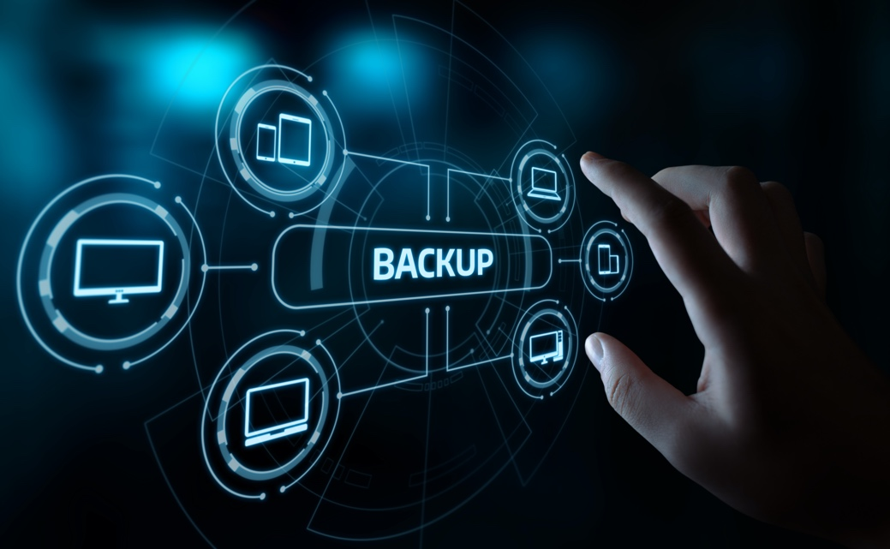

216032857 / Sikov / stock.adobe.com

## Workstations on the network



1147700213 / Monkey Business Images / shutterstock.com

Workstations in an organisation are often standardised with respect to operating system and common applications. An 'image' or 'build' is created, making it much easier to restore the workstation to a re-usable state. There is usually an IT policy that specifies an SOE for workplace workstations. Uncommon, or specific, applications are usually installed separately after the standard image is loaded.

However, users tend to customise their workstations with shortcuts, background images and screensavers, taskbar options, mouse speed and a variety of other options. Though it may be against company policy, there may be company data lurking on a user's workstation instead of being saved on the server or NAS. Therefore, before any changes are made to a workstation the hard disk should be backed up.

|  |  |
| --- | --- |
| Tip-01 | Tip |
| Staff in a client/server organisation are generally encouraged not to store data on their own hard drives. Where an organisation's data is stored on a workstation's hard drive, there must be some procedure in place to regularly back it up. One way is to have the data located in a known folder and synchronized with a cloud-based storage area, such as OneDrive. | |

|  |  |
| --- | --- |
| Weblink-01 | Weblink |
| Learn more about [Sync OneDrive files and folders](https://support.microsoft.com/en-us/office/sync-files-with-onedrive-in-windows-615391c4-2bd3-4aae-a42a-858262e42a49) [33]and how to [Automatically sync downloads to Google Drive](https://support.google.com/a/users/answer/9308834?hl=en)[34]. | |

|  |  |
| --- | --- |
| Reflection-01 | Reflect |
| Thinks about what data you have on your home computer. What would be the best way to make sure you have a backup at least once a week? Compare your findings with your colleagues. | |

## Backup solutions

An organisation will have policies that relate to the specifics of how backup will be done, this normally applies to on-site backup solutions but can be applied to cloud-based solutions.

Also, there are different types of backups. You may not need to back up all files every time you backup.

Learn more about backups:

|  |  |
| --- | --- |
| Backup policies | Backup policies include:   * the frequency of backups (daily, weekly, monthly) * the time-of-day backups are done * how long backups are kept * where backups should be stored |
| Backup types | Different options include:   * backup of selected directories * incremental backup - backup of only files that have been created or changed since the last full or incremental backup * differential backup - backup of files that have been created or changed since the last full backup. |

|  |  |
| --- | --- |
| video | Video |
| The following series of videos shows what data should be backed up, solutions, and type of backups. There are three videos in this playlist. Please use the playlist menu button in the top right corner to view all videos in this playlist. [BSBXCS402 - Backup solutions](https://www.youtube.com/embed/videoseries?list=PLr24-CFnxcCzZYxvlVZy5lBH_HbuTeP_a)[35] | |

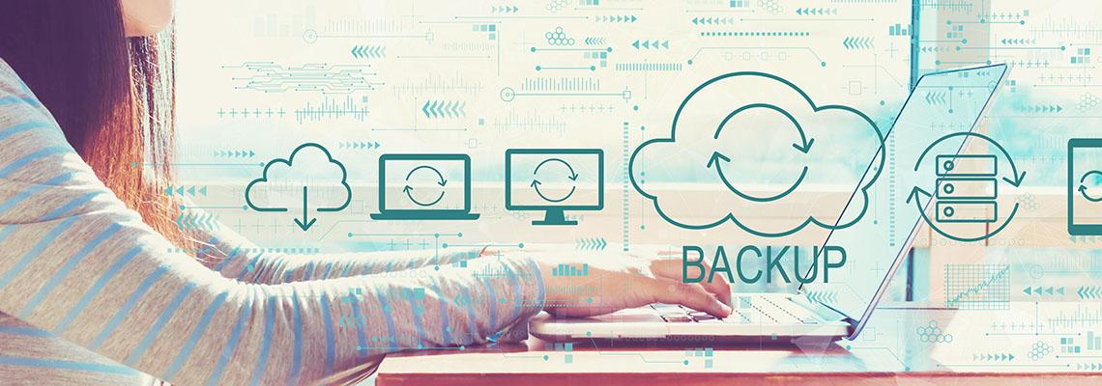

367816006 / Tierney / stock.adobe.com

## Backup scheduling

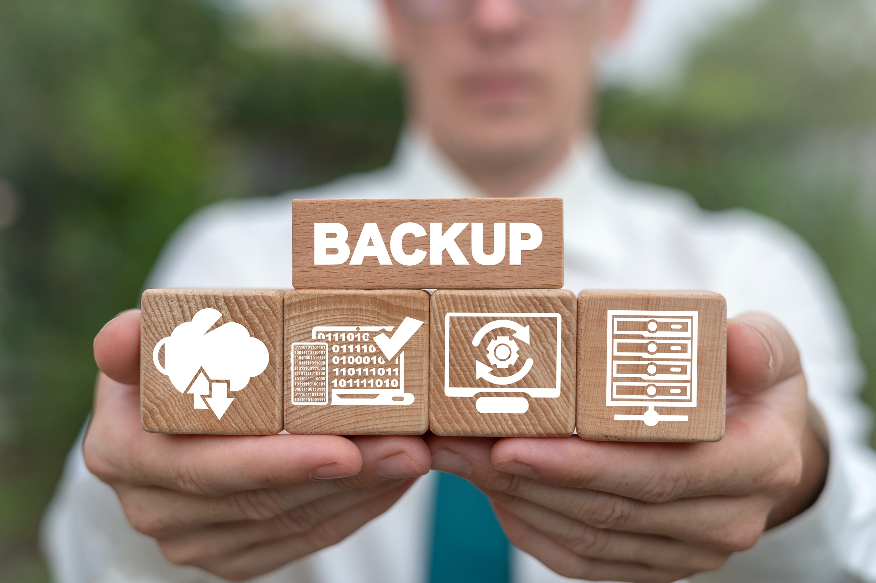

1511587799 / Panchenko Vladimir / shutterstock.com

**Backup scheduling is an important part of any preventative maintenance plan.**

Most operating system platforms provide a backup and restore tool, and this type of software is also provided by third parties. Traditionally small businesses just had the option of using a device that allowed them to remove a copy of the data off-site each day. These devices were the USB memory sticks, USB HDD, and backup tape. Now with NBN we have the added benefit of cloud storage or directly operating from a cloud-based application

|  |  |
| --- | --- |
| Cloud based storage  With any cloud-based storage there are two simple ways you can have secure data in regard to backups**.** | For micro to small businesses, you could just have your files in the cloud and access them from there, this all depends on how reliable your NBN connection is. Most accounting programs for small business, like MYOB, operate in the cloud through a cloud-base application, so your files are already secure, and no backup is required. |
| Single location storage  You could also have your files stored in a single location. | For example, on a computer, server, or NAS, and then also synchronise with your cloud storage.  For small businesses this can be as simple as having Microsoft 365 subscription that will also give you a 1TB cloud storage, and you just run the OneDrive application to setup what you need synchronised. |
| No NBN  For areas where the NBN is not reliable, or non-existent. | In this case, a small business is going to rely on the more traditional way of backing up. As in the previous table, the data size will dictate the way data is backed up. But no matter which device you backup to you are going to need a planned schedule to accomplish this. |

Look at a couple of scenarios of backup scheduling:

### Micro business



1697168977 / Girts Ragelis / shutterstock.com

* using a standalone computer
* 10GB of data
* operating from a home-based office 4 days a week
* Office hours are Tuesday to Friday 9:00am to 4:30pm
* data is located in the Documents folder

A simple solution would be to use 16GB USB 3.0 memory sticks and have a routine that runs the backup automatically at the end of each day…

**Schedule example**

|  |  |  |  |  |
| --- | --- | --- | --- | --- |
| Day | Locations | Destination | Backup Type | Time |
| Monday |  |  |  |  |
| Tuesday | \Documents | 16GB USB stick  Labelled 'Tuesday' | Differential | 4:30pm |
| Wednesday | \Documents | 16GB USB stick  Labelled 'Wednesday' | Differential | 4:30pm |
| Thursday | \Documents | 16GB USB stick  Labelled 'Thursday' | Differential | 4:30pm |
| Friday | \Documents | 16GB USB stick  Labelled 'Friday' | Full | 4:30pm |
| Saturday |  |  |  |  |
| Sunday |  |  |  |  |

### Small Business with a domain network



171921827 / Sean Locke photography / shutterstock.com

* server on a domain with an LTO tape backup drive and an UPS
* 200GB data
* real estate office that operates 7 days a week
* office hours 9:00am to 5:00pm
* all data is located on the mapped server, named 'domainserver', folder called 'Date'

**Schedule example**

|  |  |  |  |  |
| --- | --- | --- | --- | --- |
| Day | Locations | Destination | Backup Type | Time |
| Monday | \domainserver\data | LTO cartridge  Labelled 'Monday' | Incremental | 11:00pm |
| Tuesday | \domainserver\data | LTO cartridge  Labelled 'Tuesday' | Incremental | 11:00pm |
| Wednesday | \domainserver\data | LTO cartridge  Labelled 'Wednesday' | Differential | 11:00pm |
| Thursday | \domainserver\data | LTO cartridge  Labelled 'Thursday' | Incremental | 11:00pm |
| Friday | \domainserver\data | LTO cartridge  Labelled 'Friday' | Differential | 11:00pm |
| Saturday | \domainserver\data | LTO cartridge  Labelled 'Saturday' | Incremental | 11:00pm |
| Sunday | \domainserver\data | LTO cartridge  Labelled 'Sunday' | Full | 11:00pm |

|  |  |
| --- | --- |
| **Important-01** | Important |
| When using portable devices for backup, either USB connected or a tape cartridge, it is no good leaving media that is not being used in a drawer next to the backup device. These should be either locked in a fire-proof rated safe or stored off-site with a designated person. Otherwise, if the business has a fire or any other type of destruction incident, then the backup media would be lost with all the rest of the equipment. | |

|  |  |
| --- | --- |
| Activity-01 | Activity |
| **Pick a local business and make assumptions on their data size.**  Using the table in the slides above, discuss with you colleagues the device they should use for the backup, and how the schedule should be configured. | |

|  |  |
| --- | --- |
| Weblink-01 | Weblink |
| For standalone computers and devices, visit [ASCC Backing up and restoring[36]](https://www.cyber.gov.au/acsc/view-all-content/advice/backing-and-restoring) which has the following web page that contains links for:   * Backing Up and Restoring Your Files – For Mac (Using an External Storage Device) * Backing Up and Restoring Your Files – For Mac (To the Cloud) * Backing Up and Restoring Your Files – For iPhone (To the Cloud) * Backing Up and Restoring Your Files – For PC (Using an External Storage Device) * Backing Up and Restoring Your Files – For PC (To the Cloud) | |

## Topic summary and review

This topic covered the knowledge and skills needed to understand Australian Cyber Security Centre's resources, what the ReportCyber process is, and how to protect data using backups

|  |  |
| --- | --- |
| SelfCheck-01 | Self-check – Business recovery |
| When should you NOT use ReportCyber? Choose the correct response:   * You have been deceived into sending money or goods to someone online. * Someone is bullying, harassing, or stalking you online. * You have received a scam call and no loss of personal information or money has occurred.   What is one of the reasons you would perform backups in a business? Choose the correct response:   * No reason, just everyone tells you that you have to do it. * Offers peace of mind and makes it faster and easier to get up and running again. * Allows employment of an IT technician   Which one of the following would not be part of a backup policy? Choose the correct response:   * How much should be spent on backup media. * The frequency of backups. * Where backups should be stored. | |

# Cyber security – large organisations

## Introduction

All the information that you have obtained from the previous small to medium business sections is applicable to large organisations. However, with larger organisations and infrastructure comes a new set of complex layers in regard to administration and protection.

### Objectives

In this section, you will be learning information that is directly from the Australian Government, Australian Signals Directorate, Australian Cyber Security Centre web site. The information provided is gained from years of experience by IT professionals who have dedicated their profession to combating cybercrime and security of sensitive information.



77653948 / ESB Professional / shutterstock.com

## cyber.gov.au - large organisations

The Australian Cyber Security Centre (ACSC) is a useful and valuable resource for up to date and relevant information about how large Australian organisations and critical infrastructure can protect themselves from common cyber security threats.

### The ReportCyber site

* The ReportCyber process differs for the large organisations compared to the small and medium businesses. The ReportCyber process differs for the large organisations compared to the small and medium businesses.
* Not only does the site report on cybercrime, but also data breaches and cyber security vulnerability. Not only does the site report on cybercrime, but also data breaches and cyber security vulnerability.
* Each link within the page will step you through the process to report on the incident in question. Each link within the page will step you through the process to report on the incident in question.

|  |  |
| --- | --- |
| Weblink-01 | Weblink |
| Check the link to find out where to [ReportCyber](https://www.cyber.gov.au/acsc/report/large-organisations-and-infrastructure#no-back)[37] – large organisations and infrastructure. | |



1415984021 / Immersion imagery / shutterstock.com

## Large organisations

This section provides advice and guidance focused on large organisations, including strategies on how to:

* prevent and respond to cyber incidents
* ensure appropriate levels of education and awareness for your workforce
* managing supply chain risks
* communicating the importance of good cyber security to executives and customers

|  |  |
| --- | --- |
| Weblink-01 | Weblink |
| Visit this link to learn more about [prevention and response strategies for large organisations.](https://www.cyber.gov.au/acsc/organisations-and-critical-infrastructure/large-organisations)[38] Visit this link for [advice on COVID-19 themed malicious cyber activities[39]](https://www.cyber.gov.au/acsc/services/covid-19-cyber-security-advice) | |



626347238 / Sergieiev / shutterstock.com

## Strategies to mitigate cyber security incidents

|  |  |
| --- | --- |
| Weblink-01 | Weblink |
| The Australian Cyber Security Centre (ACSC) has developed focussed strategies to alleviate the impact of cyber threats on organisations. These strategies address targeted, persistent cyber intrusions, ransomware, external and internal malicious intentions and other serious cyber threats.  Visit this link to [learn more about the ACSC mitigation strategies](https://www.cyber.gov.au/acsc/view-all-content/strategies-to-mitigate-cyber-security-incidents).[40] | |

Before implementing any of the ACSC mitigation strategies, organisations must first identify their assets and perform a risk assessment to identify the level of protection required from various cyber threats. Also, organisations may need to have experienced the impact of significant, motivating cyber threat events, and would also possess the required organisational and financial resources to take action to improve their cyber security position.



1984920635 / Vectorfusionart / shutterstock.com

|  |  |
| --- | --- |
| Weblink-01 | Weblink |
| **ACSC mitigation strategies details**  Visit this link to view/download [details of ACSC mitigation strategies[41]](https://www.cyber.gov.au/sites/default/files/2021-10/PROTECT%20-%20Strategies%20to%20Mitigate%20Cyber%20Security%20Incidents%20%E2%80%93%20Mitigation%20Details%20%28February%202017%29.pdf)  **Essential Eight**  Also, visit this link to learn more about implementing ACSC's [eight essential mitigation strategies](https://www.cyber.gov.au/acsc/view-all-content/essential-eight)[42] as a baseline (known as the *Essential Eight* )  **Cyber supply chain risk management**  If a business supplies products or services to an organisation, there is the possibility of cyber supply chain risk transferring between those two entities.  Visit this link to learn more about [Cyber Supply Chain Risk Management[43]](https://www.cyber.gov.au/acsc/view-all-content/publications/cyber-supply-chain-risk-management) | |

## Critical infrastructure

Critical infrastructure in Australia provides essential, everyday services like energy, communications, water, transport, health, food and grocery, banking and finance, and the Australian Government.

The Australian Cyber Security Centre offers tailored advice and expert guidance to Critical Infrastructure partners, on implementing sound mitigation and risk reduction strategies, providing expert information about relevant technologies and managing high-risk environments.

|  |  |
| --- | --- |
| Weblink-01 | Weblink |
| Visit the ACSC website to learn more about [critical infrastructure[44]](https://www.cyber.gov.au/acsc/large-organisations-and-infrastructure/critical-infrastructure) | |

|  |  |
| --- | --- |
| DidYouKnow-01 | Did you know? |
| Aiming to protect Australians against cyber threats, the Australian Government developed its Cyber Security Strategy. Visit this link to learn more about the [Commonwealth cyber security posture.[45]](https://www.cyber.gov.au/acsc/view-all-content/reports-and-statistics/commonwealth-cyber-security-posture-2020) | |



338758796 / Lightspring / shutterstock.com

## Operational technology

The term **operational technologies** describes the technological landscape that supports and drives a cyber-connected and increasingly vulnerable system of critical infrastructure.

"A cyber-attack on an operational technology system can have consequences in the physical world which, if left unmitigated, can have a potentially major or deadly impact on society and the Australian way of life"

© Commonwealth of Australia 2020, Australian Cyber Security Centre, 11/01/22. CC BY 4.0

|  |  |
| --- | --- |
| Weblink-01 | Weblink |
| The implementation of secure operational technologies represents a significant challenge for many reasons. To learn more about what these are, visit the [Operational Technology](https://www.cyber.gov.au/acsc/large-organisations-and-infrastructure/operational-technology)[46] page on the ACSC website. | |



1549496876 / metamorworks / shutterstock.com

## Industrial control systems remote access protocol

|  |
| --- |
| External parties may need to connect remotely to critical infrastructure control networks. This access is to allow the manufacturers of equipment used in Australia's critical infrastructure the ability to maintain the equipment, when a fault is experienced that cannot be fixed in the required timeframe any other method. Such access to external parties is to be considered an extraordinary event and will only be given at critical times where granting access is required to maintain the quality of everyday life in Australia.  *© Commonwealth of Australia 2020,Australian Cyber Security Centre,(this is an external link and opens in a new window)11/01/22. CC BY 4.0(this is an external link and opens in a new window)* |

|  |  |
| --- | --- |
| Weblink-01 | Weblink |
| To learn more about cyber security considerations when creating a remote connection to a computing system visit:  [Using Remote Desktop Clients](https://www.cyber.gov.au/acsc/view-all-content/publications/using-remote-desktop-clients)[47]  [Using Virtual Private Networks](https://www.cyber.gov.au/acsc/view-all-content/publications/using-virtual-private-networks)[48] | |

|  |  |
| --- | --- |
| Weblink-01 | Weblink |
| Connecting remotely to an industrial control system has some specific considerations. To find out more advice from ICS-CERT view/download the [Configuring and Managing Remote Access for Industrial Control Systems (1.86MB pdf)](https://us-cert.cisa.gov/sites/default/files/recommended_practices/RP_Managing_Remote_Access_S508NC.pdf)[49]  The following document published by ACSC, describes two principles and one protocol. [Industrial Control Systems Remote Access Protocol[50]](https://www.cyber.gov.au/acsc/view-all-content/publications/industrial-control-systems-remote-access-protocol) | |

## Australian Government Information Security Manual (ISM)

**The Australian Government Information Security Manual** is produced by the Australian Cyber Security Centre. It contains cyber security principles and guidelines to equip organisations with strategies to protect their data and systems from cyber threats.

|  |  |
| --- | --- |
| Weblink-01 | Weblink |
| Visit this link for detailed information about [using the Australian Government Information Security Manual[51]](https://www.cyber.gov.au/acsc/view-all-content/advice/using-australian-government-information-security-manual)  To learn more about specific cyber security terminology see [Cyber Security Terminology[52]](https://www.cyber.gov.au/acsc/view-all-content/advice/cyber-security-terminology) | |

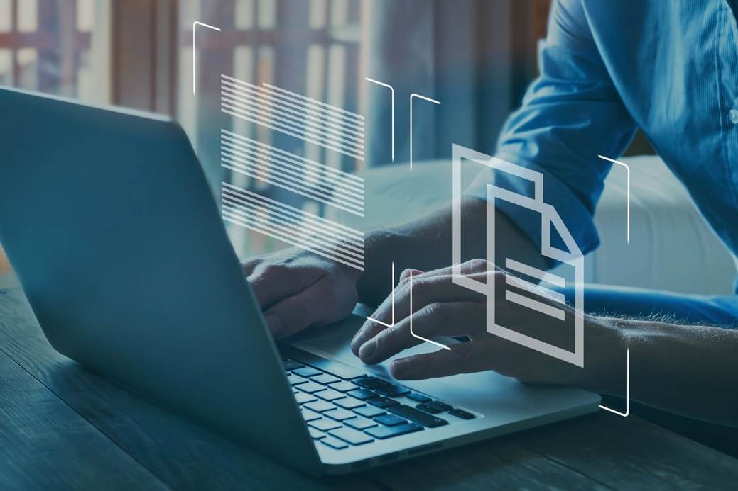

1816579838 / Song_about_summer / shutterstock.com

## Topic summary and review

This topic covered the knowledge and skills needed to understand Australian Cyber Security Centre's resources, what the ReportCyber process is, and how to protect data using backups

|  |  |
| --- | --- |
| SelfCheck-01 | Self-check – Cyber security large organisations |
| The Strategies to Mitigate Cyber Security Incidents – Mitigation Details document provided by ACSC helps organisations mitigate cyber security incidents caused by which two (2) listed below? *Choose two correct responses*:   * Ransomware denying access to data for monetary gain. * Junk emails from their competitors. * Corrupt software updates. * Malicious insiders who destroy data   The ACSC does not offer which Critical Infrastructure support? Choose the correct response:   * Technical expertise in Information and Operational Technologies * Principles-based advice tailored toward high-risk environments * Australian Computer Society   The acronym for ISM stands for ? *Choose the correct response*:   * Information Systems Manual. * Information Security Manual. * Infrastructure Security Manual.   *Check your answers at the end of this Learner Guide* | |

# Legislation, standards and policies

## Introduction

In all civilised democracies laws and regulations are developed for the good of its citizens. These laws include the way that an individual's sensitive information is handled by organisations.

This topic looks at the Privacy Act regarding the responsibilities of organisations, and the rights of individuals. Also covered are the areas of the ISO 27001 standards, NIST aims and where to access international legislation.

### Objectives

By completing this topic, you will be able to do the following:

* Understand the principles of the Privacy Act 1988.
* Understand the rights and responsibilities of organisations.
* Recognise the Australian Privacy Principals.
* Identify notifiable breaches in regard to privacy.
* Understand the Information Privacy Act 2009 (QLD).
* Understand what is the ISO 27001.
* Describe the National Institute of Standards and Technology.
* Access international legislation.



338053589 / Zerbor / shutterstock.com

## Privacy Act 1988



730538191 / Vitalii Vodolazskyi / shutterstock.com

The Privacy Act 1988 was introduced to regulate the handling of personal information by large private sector and public sector organisations, including most Australian Government agencies. Such personal information includes details of tax file numbers, credit information and health or medical related data.

### Rights and responsibilities

|  |  |
| --- | --- |
| Weblink-01 | Weblink |
| Visit the [Rights and Responsibilities[53]](https://www.oaic.gov.au/privacy/the-privacy-act/rights-and-responsibilities) page on the Office of the Australian Information Commissioner for detailed answers to the following questions:   * Who has rights under the Privacy Act? * Who has responsibilities under the Privacy Act? * What is an organisation? * What small businesses are covered? * Who doesn't have responsibilities under the Privacy Act? | |

|  |  |
| --- | --- |
| video | Video |
| Watch the following video from Court Lawyers, which discusses [Privacy Law in Australia](https://www.youtube.com/embed/MQc-UjE560A?rel=0)[54] | |

|  |  |
| --- | --- |
| Activity-01 | Activity |
| Visit the [Small Business[55]](https://www.oaic.gov.au/privacy/privacy-for-organisations/small-business) and read about the following topics:   * the obligations of a small business covered by the Privacy Act * whether or not a small business must comply with the Privacy Act. * What happens if your business breaches the Privacy Act? | |

## Australian privacy principles



369815300 / Jirsak / shutterstock.com

**The Australian Privacy Principles (APP) guidelines** outline the mandatory requirements of the APPs, how we will interpret the APPs, and matters we may consider when exercising our functions and powers under the Privacy Act 1988 (Privacy Act).

Both the APPs and the APP guidelines apply to any organisation or agency the Privacy Act covers. The Privacy Act covers Australian Government agencies and organisations with an annual turnover of more than $3 million, and some other organisations.

|  |  |
| --- | --- |
|  | Weblink |
| For more information on this topic visit the OAIC website [Australian Privacy Principles guidelines](https://www.oaic.gov.au/privacy/australian-privacy-principles-guidelines)[56] | |

### The Australian Privacy Principles guidelines cover the following areas:

|  |  |
| --- | --- |
| * Key concepts | * Use or disclosure of personal information |
| * Permitted general situations | * Direct marketing |
| * Permitted health situations | * Cross-border disclosure of personal information |
| * Open and transparent management of personal information | * Adoption, use or disclosure of government related identifiers |
| * Anonymity and pseudonymity | * Quality of personal information |
| * Collection of solicited personal information | * Security of personal information |
| * Dealing with unsolicited personal information | * Access to personal information |
| * Notification of the collection of personal information | * Correction of personal information |

## Notifiable data breaches

When personal information or data experiences an unauthorised access, loss or disclosure, this is called a Data Breach. The Notifiable Data Breaches scheme dictates that if a data breach is likely to cause serious harm, this constitutes a notifiable data breach, meaning that the owner of the personal information or data must be notified of the breach.

|  |  |
| --- | --- |
| Example-01 | Example |
| Some examples of data breaches would be:   * the loss or theft of a USB or mobile phone containing personal information * a hacked database that contains personal information * personal information incorrectly or deliberately sent to an unauthorised person. | |

|  |  |
| --- | --- |
| Weblink-01 | Weblink |
| Please visit the following links to learn more about data breach processes and procedures: [What is a notifiable data breach?](https://www.oaic.gov.au/privacy/data-breaches/what-is-a-data-breach)[57] [Data breach response](https://www.oaic.gov.au/privacy/guidance-and-advice/data-breach-preparation-and-response)[58] [Exceptions to data breach notification](https://www.oaic.gov.au/privacy/guidance-and-advice/data-breach-preparation-and-response/part-4-notifiable-data-breach-ndb-scheme#exceptions-to-notification-obligations)[59] [Civil penalties for data breaches](https://www.oaic.gov.au/about-us/our-regulatory-approach/guide-to-privacy-regulatory-action/chapter-6-civil-penalties)[60] | |

|  |  |
| --- | --- |
| Tip-01 | Tip |
| **Phishing scams**  A phishing scam tricks you into providing personal information (eg. bank account details or passwords). In emails, if you don't recognise the organisation or agency that has contacted you, don't click on contained links. Don't share personal information over the 'phone with unknown callers. Avoid clicking on links in emails or sharing your personal information on the phone or by email, unless you are certain the organisation or agency that has contacted you is genuine. Contact the organisation or agency instead through publicly available contact details (such as the phone book or their website).  If in doubt, make direct contact with agencies to verify information. | |

## Information Privacy Act 2009 (QLD)

The Queensland Information Privacy Act 2009 (the Act) provides rules and principles applicable only to Queensland government public service organisations and agencies, outlining the rights of individuals regarding the collection, handling, right of access and amendments, of individuals' personal information.

|  |
| --- |
| **The meaning of personal information**  Personal information is information or an opinion, including information or an opinion forming part of a database, whether true or not, and whether recorded in a material form or not, about an individual whose identity is apparent, or can reasonably be ascertained, from the information or opinion.  *Information Privacy Act 2009 - Sect 12 CC BY 4.0 Sourced from the Queensland Legislation website at 11/01/22.* |

|  |  |
| --- | --- |
| Weblink-01 | Weblink |
| To view the Act, visit [Information Privacy Act 2009[61]](https://www.legislation.qld.gov.au/view/whole/html/inforce/current/act-2009-014) | |



568424494 / Tuangtong Soraprasert / shutterstock.com

## ISO 27001

|  |  |  |
| --- | --- | --- |
| * Technology | * Control | * Certification |
| * Standards | * Security | * Verified |

|  |  |
| --- | --- |
| * ISO 27001 is also referred to as ISO/IEC 27001 | * There are more than 12 standards in the ISO/IEC 27000 family. These standards, when applied by organisations, will facilitate managing the security of resources such as intellectual property, financial information, employee details or information entrusted by third parties. |
| * ISO 27001 (ISO/IEC 27000) outlines requirements for an information security management system (ISMS). |
| * The ISO/IEC 27001:2013 standard stipulates the requirements for establishing, implementing, maintaining, and continually developing an information security management system within the framework of the organisation. | |
| * The ISO/IEC 27001:2013 standard additionally includes requirements for the appraisal and management of information security risks customised to the needs of the organisation. The requirements set out in the ISO/IEC 27001:2013 standard is universal and are intended to be applicable to all organisations, irrespective of type, size, or type. | |

|  |  |
| --- | --- |
| Weblink-01 | Weblink |
| To learn more about this standard see [Review of the ISO/IEC 27001:2013 Information technology — Security techniques — Information security management systems — Requirements[62]](https://www.standards.org.au/standards-catalogue/sa-snz/communication/it-012/as--iso-slash-iec--27001-colon-2015) | |

## National Institute of Standards and Technology (NIST)

**Who is NIST?**

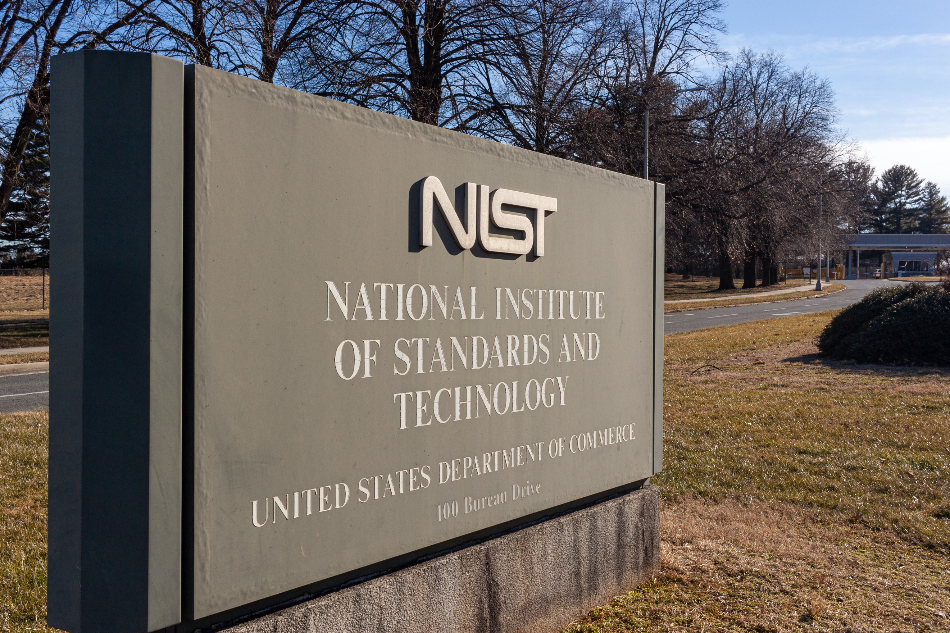

1909114186 / grandbrothers / shutterstock.com

NIST is currently part of the United States Department of Commerce and is one of the USA's oldest physical science laboratories. NIST, founded in 1901, was created by the United States Congress to remove what was, at the time, a serious challenge to U.S. industrial effectiveness which was trailing behind that of Germany, United Kingdom and other economies.

NIST measurements now provide for the smallest to the largest of technologies and the most complicated of man-made innovations, from nanoscale mechanisms so tiny that tens of thousands can fit on the end of a single human hair, to earthquake-resistant buildings and worldwide communication networks.

**The NIST Privacy Framework**

The NIST Privacy Framework is a voluntary tool developed in cooperation with stakeholders intended to help organisations to develop privacy guidance, tools, and international standards.

|  |  |
| --- | --- |
| video | Video |
| To learn more watch these two videos on [NIST (National institute of standards)](https://www.youtube.com/embed/videoseries?list=PLr24-CFnxcCzasrRNReScrWHP1XtviM-E)[63] and the NIST privacy framework.  There are two videos in this playlist. Please use the playlist menu button in the top right corner to view all videos in this playlist. | |

|  |  |
| --- | --- |
| Weblink-01 | Weblink |
| NIST has released their version of the [Privacy Framework: A tool for improving privacy through enterprise risk management, version 1.0](https://nvlpubs.nist.gov/nistpubs/CSWP/NIST.CSWP.01162020.pdf)[64]. As the title suggests it is a tool to help enhance positive uses of data while protecting individual privacy. | |

## International legislation

There are numerous countries that have privacy laws, however, there are also numerous countries that do not. These countries that have weak or no privacy laws at all are normally based in despotism or totalitarian government systems.

* The United Nations Conference on Trade and Development (UNCTAD) has a tool called Global Cyberlaw Tracker that covers global mapping of cyberlaws.
* At the time of writing, 66% of countries had legislation for data protection and privacy, while 19% had none. The other percentages were 10% in draft, and 5% with no data.
* Although 66% of countries have a form of privacy legislation, the strength of the legislation will vary depending on the freedom of democracy they enjoy.

|  |  |
| --- | --- |
| Weblink-01 | Weblink |
| Visit [Australian Privacy Foundation](https://privacy.org.au/)[65], a great web site dedicated to protecting the privacy rights of Australians. The site also provides information and links on the [privacy laws of about 30 countries](https://privacy.org.au/resources/privacy-law/plawsworld/)[66](Privacy Laws of the World).  Also, visit the United Nations Conference on Trade and Development site for [Data Protection and Privacy Legislation Worldwide](https://unctad.org/page/data-protection-and-privacy-legislation-worldwide)[67] | |



1091235845 / Alexandros Michailidis / shutterstock.com

## Topic summary and review

This topic covered the knowledge and skills needed to understand the Privacy Act and the Acts components. The topic also covered the rights and responsibilities of organisations and the different legislation apart from the Privacy Act.

|  |  |
| --- | --- |
| SelfCheck-01 | Self-check – Legislation standards and policies |
| In what year was the Privacy Act enacted   * 1984 * 1988 * 1996   The Queensland Information Privacy Act 2009 covers all businesses in Queensland   * True * False   What ISO 27001 standard includes the appraisal and management of information security risks:   * ISO/IEC 27001:2013 * ISO/IEC 27001:2015 * ISO/IEC 27002:2013   *Check your answers at the end of this Learner Guide* | |

# Company policies

## Introduction

Most organisations will have some form of company policy to ensure that everyone involved with the organisation has the same ideas and principles.

This topic looks at what a privacy policy is, and the way personal information is handled within the organisation.

The topic will also discuss storage of personal information and how privacy affects the organisation's website.

### Objectives

By completing this topic, you will be able to do the following:

|  |  |
| --- | --- |
| * Understand what a privacy policy is. | * Explain the control and rights of a customer's personal information. |
| * Understand the collection of personal information. | * Understand the security and storage of personal information. |
| * Know the parameters of the use and disclosure of personal information. | * Understand cookies and third-party sites consent clauses for websites. |



173793329 / docstockmedia / shutterstock.com

## Privacy policy



489852166 / Rawpixel.com / shutterstock.com

Company policies usually describe workplace expectations for both employee and employer. Different types of organisations will have differing company policy needs, but most organisations will at least have policies in place that outline company expectations for:

|  |  |
| --- | --- |
| * conduct | * use of personal information |
| * privacy | * equity and equality |
| * data protection | * workplace internet and social media use. |
| * health and safety |  |

Learn more about privacy-related issues that affect company policies:

|  |  |
| --- | --- |
| Privacy policy | If your organisation, business, or company collects personal information data online or directly from your customers, you must use a privacy policy. By law businesses are required to have a privacy policy if they sit within one of the conditions set out in the Privacy Act 1988. |
| Collection of personal information | In connection with carrying out their work, organisations and agencies may sometimes need to collect your personal information, but they can only collect personal information that is strictly necessary for their work. Australian privacy law dictates what personal information these parties can collect and the information they need to provide to you in that regard. |

|  |  |
| --- | --- |
| Note-01 | Note |
| They will only need your consent if the personal information being collected is "sensitive". See below weblink for more information. | |

|  |  |
| --- | --- |
| Notification after collection of personal information | If an organisation or agency collects personal information, they must take reasonable steps to inform the individual, as soon as possible after collecting it. The collecting organisation or agency must provide their contact details and identity, and several other details to the individual whose personal information has been collected. To learn more on this topic, see Australian Privacy Principles, Chapter 5 |
| Use and disclosure of personal information | Personal information may only be used or disclosed for the primary purpose for which it was collected. Exceptions to this would include if the individual consents or expects such use or disclosure. (OAIC,2021. For the rules and exceptions of overseas use and disclosure of personal information, see Chapter 8 of the Australian Privacy Principles. See below weblink for more information. |
| Security and storage of personal information | Organisations or agencies must take reasonable steps to protect the personal information they have collected, from any kind of interference, loss, unauthorised access, or misuse. Unless an exception applies, they are also required to destroy or repress identities of such personal information once it is no longer needed. The OAIC provides a guide on this topic. See below weblink for more information |
| Unsolicited personal information | Sometimes an organisation or agency may receive your personal information when they have not asked for it. For example, they may receive misdirected mail.  How the organisation or agency handles such a situation is explained in the APP Guidelines, Chapter 4. See below weblink for more information |

|  |  |
| --- | --- |
| Weblink-01 | Weblink |
| For more information go the OAIC.gov:  See [What is sensitive information](https://www.oaic.gov.au/privacy/your-privacy-rights/your-personal-information/what-is-personal-information#SensitiveInfo)[68]  For the rules and exceptions of overseas use and disclosure of personal information, see [Chapter 8 of the Australian Privacy Principles.[69]](https://www.oaic.gov.au/privacy/australian-privacy-principles-guidelines/chapter-8-app-8-cross-border-disclosure-of-personal-information)  For a [Guide to securing personal information](https://www.oaic.gov.au/privacy/guidance-and-advice/guide-to-securing-personal-information)[70]  Dealing with unsolicited personal information can be found in the [APP Guidelines](https://www.oaic.gov.au/privacy/australian-privacy-principles-guidelines/chapter-4-app-4-dealing-with-unsolicited-personal-information).[71] | |

|  |  |
| --- | --- |
| Weblink-01 | Weblink |
| Visit these links for information about creating a [Privacy Policy](https://lawpath.com.au/legal-documents/privacy-policy) [72] and [How to Write a Privacy Policy for Your Website](https://legal123.com.au/how-to-guide/privacy-policy-australia/).[73] | |

|  |  |
| --- | --- |
| **Important-01** | Important |
| For more information about the collection of solicited personal information see the [Australian Privacy Principles (APP) Guidelines](https://www.oaic.gov.au/privacy/australian-privacy-principles-guidelines/chapter-3-app-3-collection-of-solicited-personal-information)[74] | |

## Websites- cookies and third-party sites consent clauses

|  |  |
| --- | --- |
| Note-01 | Note |
| A 'cookie' is a small file in your web browser. Cookies gathers data about your web browsing behaviour. Even though cookies do not access information stored on your computer, or any personal files, they do allow collection of identifiable information. Use of cookies allows a website to customise its structure to your needs and likings, as well as possibly serve ads to you while you are browsing the Internet. | |

If you have a web site that collects personal information you need to state the way in which the information is collected.

|  |  |
| --- | --- |
| Tip-01 | Tip |
| **Should my privacy policy include a notification about 'cookies'?**  Yes. A business privacy policy should include a 'cookie' notification section if you are gathering information via a web site. | |

|  |  |
| --- | --- |
| Weblink-01 | Weblink |
| For detailed information about this topic download/view this comprehensive OAIC publication [Cookies and Other Online Identifiers[75]](https://www.oaic.gov.au/__data/assets/pdf_file/0017/2465/20-06-15-research-paper-for-oaic-online-identifiers.pdf) | |



76457401 / Dinga / shutterstock.com

## Email lists, registrations, and feedback

|  |  |
| --- | --- |
| Tip-01 | Tip |
| A business will collect information that is provided to them when a user signs up to mailing lists, registers for events, or when submitting feedback on their experience with the business's website. | |

There are applications that manage mailing lists and event registrations. Vendors of such applications should have a link to a privacy policy.

When subscribing to a mailing list, the person will be asked for their express consent that the managing application may use their data for analytics purposes. Analytics are performed when the user clicks on links in the email, or when they download the images in the email.

This includes which emails you open, which links you click, your mail client (e.g., 'Outlook" or 'iPhone'), if the action occurred on 'mobile' or 'desktop', and the country geolocation of the IP address (the IP address itself is not stored).

|  |  |
| --- | --- |
| Registering for an event | When registering for an event, you may be required to give personal information (name, address, telephone number and email address). You may also be required to provide financial information (credit card number, expiration date) if paying for an event. The booking application may share some of your personal information, including information about whether a particular registered individual has made payment, but should not receive your financial information. |
| Feedback applications | Feedback applications conduct anonymous stakeholder surveys to gather feedback to help the business improve their performance. Information about how the feedback application manages personal information should be available in the privacy and data collection policies on their website. |

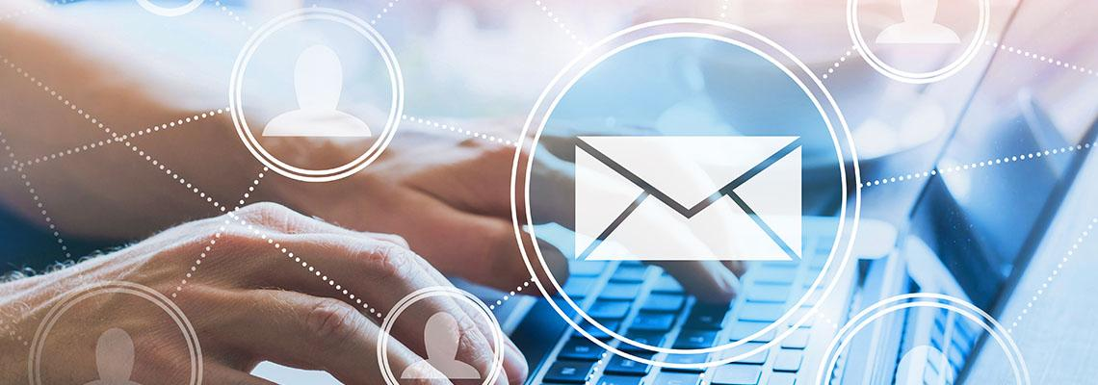

1138036256 / Song_about_summer / shutterstock.com

## Topic summary and review

This topic covered the knowledge and skills needed to understand the privacy policies within an organisation and the requirements for the collection, use, and disclosure of personal information. Other areas in this topic were the security and storage of personal information and websites.

|  |  |
| --- | --- |
| SelfCheck-01 | Self-check – Company policies |
| The Privacy Act allows an individual to ? Select the correct response:   * have the option of not identifying yourself, or of using a pseudonym in certain circumstances * ask for access to your personal information (including your health information) * stop receiving unwanted direct marketing * all the above   A privacy policy could also be known as a responsible use of data policy   * True * False   The Office of the Australian Information Commissioner has released a guide for securing personal information called?   * Guide to securing personal information - ‘Reasonable steps’ to protect personal information” * Guide to securing personal information - ‘The step-by-step to protect personal information” * Guide to securing personal information - ‘Nearly all steps’ to protect personal information”   *Check your answers at the end of this Learner Guide* | |

# Data

## Introduction

Every transaction you do, any information you read, and any program or app you run is made up of data. Some of this data is just raw information that runs a program, and some is highly sensitive personal information.

This topic takes a look at understanding what type of data relates to a person's personal information and how it is classified.

### Objectives

By completing this topic, you will be able to do the following:

* Understand what data is.
* Determine what sensitive data is.
* Understand what personally identifiable information is.
* Identify sensitive data.
* Classify data.



1499306735 / jamesteohart / shutterstock.com

## What is data?



785530237 / Yuri Hoyda / shutterstock.com

In information technology, 'data' are the bits and bytes stored in memory or a storage device, encapsulated in what is termed 'packets'.

However, the way we will look at data in the terms of this unit is information that is stored, collected, or shared. Information as data on a computer will take form in the shape of files, such as the common Microsoft Word.docx file.

Let us have a look at a small business that is in the engineering section and produces design and CAD drawings for structural steel.

Learn about some of the data that the company may have:

|  |  |
| --- | --- |
| Common business files | * Word processing * Spreadsheets * Bookkeeping * Wages |
| Industry specific files | * Design concepts * Detailed drawings * Specifications |
| Customer relations files | * Client contact information and company details * Personal information from web site contacts |

|  |  |
| --- | --- |
| Note-01 | Note |
| The data has different importance attached, the differences could be personal, intellectual property, copyrights, trademarks, financial, etc. Each of these types of data brings with it a risk in privacy that can affect individuals and businesses. | |

## Sensitive data

|  |  |
| --- | --- |
| Tip-01 | Tip |
| Sensitive data is information that must always be protected against unauthorised access by malicious parties. | |

To prevent unauthorised access to sensitive data there should always be sufficient data security, and information security policies and procedures in place to prevent any data disclosure or data breaches.

An organisation may have to guard against unauthorised access to sensitive data for legal or ethical requirements, also regulatory reasons, trade secrets, personal privacy, and critical business data.

|  |  |
| --- | --- |
| **Important-01** | Important |
| Any breaches to access of sensitive data can cause irreparable damage to the organisation in regard to client trust and industry representation. This could also lead to not just financial loss to the business but also breaches to Australian law where the organisation and directors or owners, could be exposed to penalties such as fines or imprisonment. | |

|  |  |
| --- | --- |
| Weblink-01 | Weblink |
| For detailed definition of Sensitive Information see the Australian Law Reform page on [Sensitive Information[76]](https://www.alrc.gov.au/publication/for-your-information-australian-privacy-law-and-practice-alrc-report-108/6-the-privacy-act-some-important-definitions/sensitive-information/) | |

|  |  |
| --- | --- |
|  | Research |
| Create a list of the sensitive information held about TAFE Queensland students by the organisation. Compare your list with your colleagues and discuss any differences. | |

## Personally identifiable information

|  |  |
| --- | --- |
| Note-01 | Note |
| According to the OAIC (2021), the Privacy Act defines 'personal information' as: *Information or an opinion about an identified individual, or an individual who is reasonably identifiable.* | |

**Key points from the Privacy Act:**

* Information does not have to be explicitly recognised as personal information to constitute personal information.
* The definition of personal information is not limited to information about an individual's private or family life.
* Personal information can range from sensitive and confidential information to information that is publicly available.

|  |  |
| --- | --- |
| Example-01 | Example |
| Examples may include information about a person's name, birth date, account details, employment status, health records, salary, bank and other loans and more. To learn more see [types of personal information[77]](https://www.oaic.gov.au/privacy/guidance-and-advice/what-is-personal-information) on the OAIC website. | |

|  |  |
| --- | --- |
| Weblink-01 | Weblink |
| Visit the OAIC site to find out more about [definitions of personal information[78]](https://www.oaic.gov.au/privacy/guidance-and-advice/what-is-personal-information)  Also, view/download the OAIC publication [What is personal information?[79]](https://www.oaic.gov.au/privacy/guidance-and-advice?a=2832) | |

**Sensitive data**

|  |  |
| --- | --- |
| Weblink-01 | Weblink |
| **Identifying sensitive data**  For information about identifying sensitive data visit the Australian Law Reform page [Sensitive information[80]](https://www.alrc.gov.au/publication/for-your-information-australian-privacy-law-and-practice-alrc-report-108/6-the-privacy-act-some-important-definitions/sensitive-information/) | |

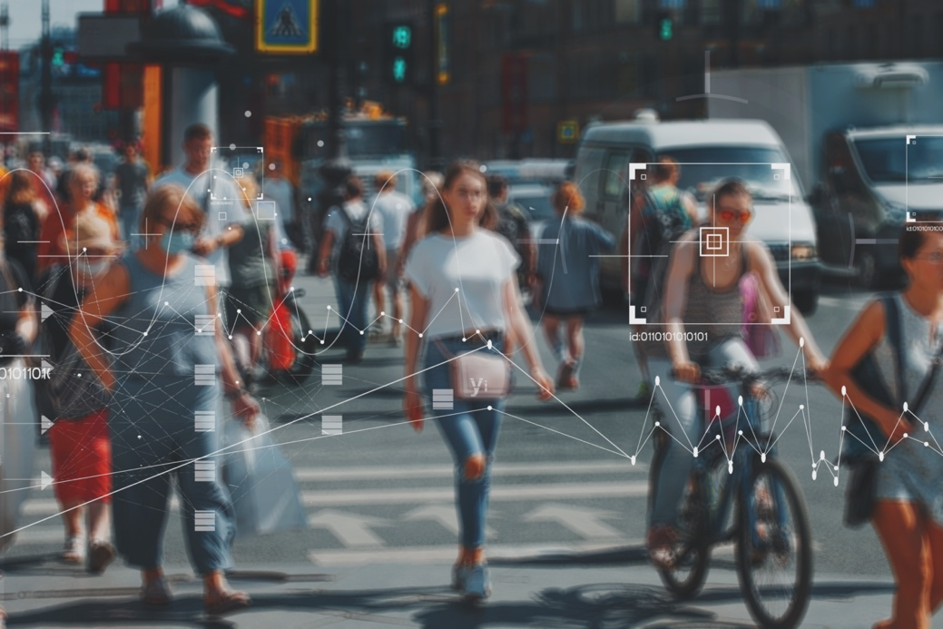

1783535000 / Trismegist san / shutterstock.com

## Classifying data

Information collected from various sources including staff and clients, needs to be classified by its type. If you are getting publicly available information for a simple project like a phone book, this information would not be classified as sensitive.

However, if the information you are collecting is attached to financial or health records, containing for example tax file numbers or personal medical information, then the information would be classified as sensitive.

|  |  |
| --- | --- |
| Note-01 | Note |
| Both non-sensitive and sensitive types of information are protected under Australian Privacy law. | |

|  |  |
| --- | --- |
| Weblink-01 | Weblink |
| **Intellectual property (IP)**  IP can also be classified a sensitive. Intellectual property is property knowledge, also known as the property of your mind. This can be design, trademark, an invention, a brand, or even the application of your idea.  Although the privacy act does not include intellectual property you should always consider if the data you are handling is sensitive or not.  For more information about intellectual property please see [IP explained.[81]](https://www.ipaustralia.gov.au/understanding-ip/getting-started-ip/ip-explained) | |



276082040 / JNT visual / shutterstock.com

## Topic summary and review

This topic covered the knowledge and skills needed to understand what data is, especially sensitive data. Other areas in this topic were what personally identifiable information is, and how to identify and classify data.

|  |  |
| --- | --- |
| SelfCheck-01 | Self-check - Data |
| Types of personal information can include ‘health information’, ‘credit information’, and ‘tax file number information’.   * True * False   Which one of the following is defined in the Privacy Act as sensitive information?   * Sports club membership * Racial or ethnic origin * Opinion of the best NRL team   *Check your answers at the end of this Learner Guide* | |

# Sending and receiving sensitive data

## Introduction

Every microsecond of the day information is back and forth from a point A to a point B. This normally does not matter until the information becomes personal and sensitive.

This topic looks at understanding how we collect sensitive information, and the risks involved. The topic also looks at the way we send information in regard to being unsecured and secured.

### Objectives

By completing this topic, you will be able to do the following:

* Understand the information life cycle.
* Understand the basics of sending and receiving unsecured data.
* Understand the basics of sending and receiving secured data.

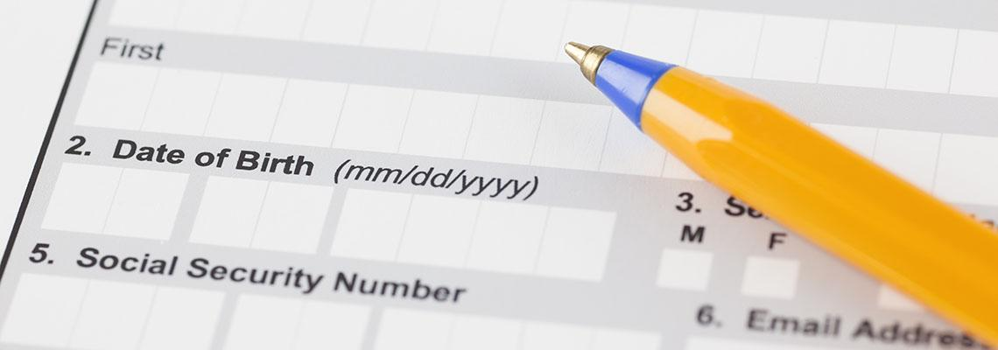

232294762 / Ekaterina_Minaeva / shutterstock.com

## The information life cycle

|  |  |
| --- | --- |
| Note-01 | Note |
| If you handle personal information, you should consider how you will protect personal information during the stages of its life cycle.  To effectively protect personal information throughout its life cycle, you will need to be aware of when and how you are collecting it and when and how you hold it. Your personal information holdings can be dynamic and change without any conscious or deliberate action. | |

### Personal Information Lifecycle

Personal information security throughout the life cycle involves asking…

1. To conduct your function or activity, is it really necessary to collect and hold personal information?
2. How will privacy protections be embedded in information-handling, to protect personal information?
3. Aside from “business as usual”, what risks are associated with collecting personal information, considering new acts, practices or project changes?
4. What steps and strategies will exist, and are these appropriate for protecting the personal information held?
5. How will the no longer needed personal information be destroyed or de-identified?

|  |  |
| --- | --- |
| Privacy by design  APP 1 outlines the requirements for APP entities to manage personal information in an open and transparent way. This includes taking reasonable steps to implement practices, procedures and systems that will ensure compliance with the APPs. The OAIC refers to this as 'privacy by design'. Privacy should be incorporated into your business planning, staff training, priorities, project objectives and design processes, in line with APP1. | You should design your personal information security measures with the aim to:   * prevent the misuse, interference, loss or unauthorised accessing, modification, or disclosure of personal information * detect privacy breaches promptly * be ready to respond to potential privacy breaches in a timely and appropriate manner |

|  |
| --- |
| Embedding security obligations  You will be better placed to meet your personal information security obligations if you embed them early, including by choosing the appropriate technology and by incorporating measures that are able to evolve to support the changing technology landscape over time. You also need to take into account the rapid development of new and existing technologies and platforms when designing your information security policies and systems. |
| Assessing the risks  An important element of 'privacy by design' is to integrate privacy into your risk management strategies.  Robust internal personal information-handling practices, procedures and systems can assist you to embed good personal information handling practices and to respond effectively in the event a privacy breach occurs.  Assessing the security risks to personal information is also an important element of 'privacy by design'. You can assess your personal information security risks by conducting a privacy impact assessment (PIA), an information security risk assessment and regular reviews of your personal information security controls. |
| Regular reviews  You should use PIAs and information security risk assessments along with regular reviews so that you are aware of the variety of security risks you face, including threats and vulnerabilities, along with the possible impacts before designing and implementing your personal information security framework. They will also assist you in integrating privacy into your risk management strategies. |

**Undertaking a privacy impact assessment**

|  |  |
| --- | --- |
| Weblink-01 | Weblink |
| Visit this page for detailed information about [undertaking a Privacy Impact Assessment[82]](https://www.oic.qld.gov.au/guidelines/for-government/guidelines-privacy-principles/privacy-compliance/overview-privacy-impact-assessment-process/undertaking-a-privacy-impact-assessment) | |

## Privacy Impact Assessment (PIA)

|  |  |
| --- | --- |
| Tip-01 | Tip |
| A privacy impact statement (PIA) is a written assessment that identifies the privacy impacts of a proposal and sets out recommendations for managing, minimising, or eliminating those impacts. | |

A PIA should analyse, assess and describe:

* the personal information flows in a proposal
* the potential privacy impacts of those flows
* the impact the overall project may have on individual privacy
* how those impacts will be eliminated or minimised.

|  |  |
| --- | --- |
| Weblink-01 | Weblink |
| The OAIC provides a detailed, **free e-learning course** on [how to conduct a Privacy Impact Assessment for your organisation](https://education.oaic.gov.au/elearning/pia/welcome.html)[83] | |

**Information security risk assessment**

|  |  |
| --- | --- |
| Tip-01 | Tip |
| You may also need to conduct an information security risk assessment (also known as a threat risk assessment) in conjunction with a PIA. An information security risk assessment is generally more specific than a PIA. | |

The information security risk assessment:

* identifies and evaluates security risks (threats and vulnerabilities) and their potential impacts on information handled by an entity.
* is an ongoing process which may be undertaken across your business generally
* should inform, together with the PIA, the development of risk management and information security policies, plans and procedures.

|  |  |
| --- | --- |
| Note-01 | Note |
| Once risks have been identified and considering the evolving nature of security risks, regular review and monitoring of information security controls (virtual and physical) should follow. Such reviews should determine if the risk management and information security policies, plans and procedures in place are adequate in mitigating the risks. | |

|  |  |
| --- | --- |
| Weblink-01 | Weblink |
| **Risk of human error**  Human error is regularly claimed as the cause of privacy incidents, so entities should assume that human error will occur and design for it.  See [the Department of Immigration and Border Protection: Own motion investigation report[84]](http://www8.austlii.edu.au/cgi-bin/viewdoc/au/cases/cth/AICmrCN/2014/5.html) for an interesting report on how human error resulted in a major breach of personal information. | |

|  |  |
| --- | --- |
| Strategies to protect personal information | Once your entity has collected and holds personal information, you need to consider what appropriate security measures are required to protect the personal information. This will need to be considered in regard to all of your entity's acts and practices. |
| Destroy or de-identify personal information | Under APP 11.2, APP entities must also take reasonable steps to destroy or de-identify the personal information they hold once it is no longer needed for any purpose for which it may be used or disclosed under the APPs. |

|  |  |
| --- | --- |
| Weblink-01 | Weblink |
| For more information on this topic, see the [OAIC guide to securing personal information](https://www.oaic.gov.au/privacy/guidance-and-advice/guide-to-securing-personal-information)[85] | |

## Sending and receiving unsecured data

|  |  |
| --- | --- |
| Note-01 | Note |
| **What is unsecured data?**  There are many definitions of unsecured data, the first one that come to mind is where data is available to the public and contains sensitive information. | |

Unsecured data describes a situation where information becomes unintentionally available via a system breach, either a network infrastructure or storage system. These breaches may be caused by mismanagement or malicious hacking.

Common platforms where information can become public are emails and public file sharing services, for example Dropbox.

An organisation's own computer network, especially when Wi-Fi or WAN is part of the IT infrastructure, is another risky area. If any part of the network is not properly configured for security, it poses risks of hacking and public disclosure of information.

|  |  |
| --- | --- |
| **Transmitting unsecured data** | As mentioned above emails and public file sharing services can provide access to the public and therefore the data is unsecured. Data attached to emails can be easily hacked during transmission of data packets from the host to the destination.  Some of the big-name email services like Gmail and Yahoo do not provide end to end encryption for your emails. When you send an email, it passes through several insecure servers that are vulnerable to hacking and other dangerous things.  Public file sharing services are not designed to cater for sensitive data as a default setting. Businesses need to be aware that when using public file sharing services, they are exactly what the name implies, so therefore businesses should not use these types of file sharing services where sensitive information could be transmitted to by accident.  Another way of transmitting unsecured data is by using external storage devices such as USB memory sticks or USB hard drives. Numerous times staff members will use a USB memory stick to transport data from one work location to another and not be aware that the memory stick that they carry could be unsecured. Most people are oblivious that USB storage devices have the capability of being either encrypted or have a data lock activated. Any type of USB storage device should be discouraged for use of transmitting data from one location to another, as these devices can be either easily lost or stolen. And if sensitive information were on these USB storage devices, the data could easily become public. |

|  |  |
| --- | --- |
| Receiving unsecured data | There are a number of ways of receiving unsecured data, it can be through emails or transferring of information from one source to yourself. Unsecure data can come in many forms, it can be sensitive information that you receive where the sender has not secured the data by encryption or other secure means. This can be by accident, by negligence in the form of not caring, or where the sender is doing it for malicious purposes.  If you receive unsecured data with sensitive information you have to report it to the Office of the Australian Information Commissioner as a breach. Breaches of the Privacy Act can have consequences for both the sender and the receiver.  To battle against unsecured data being received by the organisation, you require not only good IT management but also an industry strength security suite, plus well-trained staff in regard to handling emails, attachments, and data. |

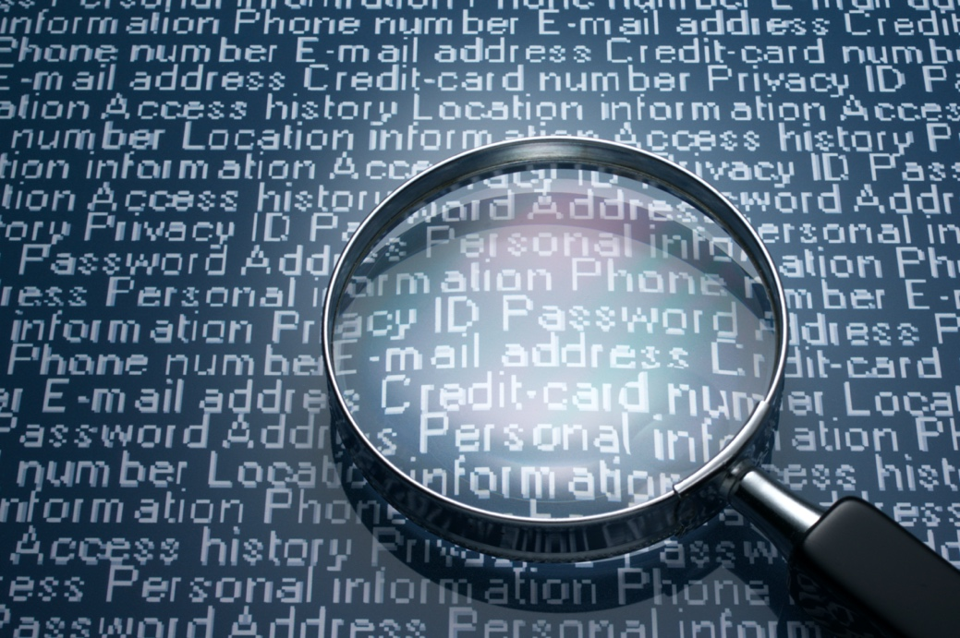

194382434 / tadamichi / shutterstock.com

## Sending and receiving secure data

Sending and receiving secure data is not just pressing a button and assuming that the process is done. Background policies and procedures must be in place to ensure that organisations can securely send and receive sensitive information data.

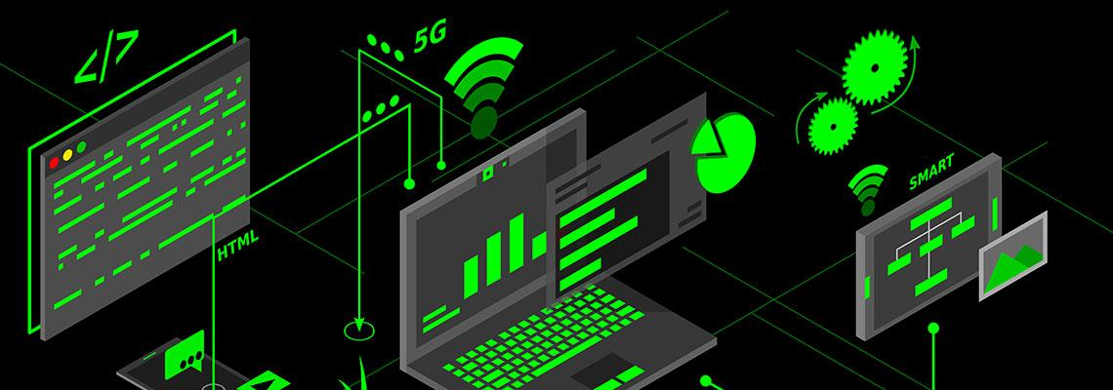

1838253076 / Aozora21 / shutterstock.com

|  |  |
| --- | --- |
| Weblink-01 | Weblink |
| Visit this page to find out more about [handling and protecting the security of personal information](https://www.oaic.gov.au/privacy/guidance-and-advice/guide-to-securing-personal-information)[86] | |

|  |  |
| --- | --- |
| Email security  The OAIC advises that 'email is not a secure form of communication' and that therefore procedures must be developed to 'manage the transmission of personal information via email'. | In their guide to protecting personal information , OAIC advises to:   * avoid sending personal/sensitive information via unsecured email * use secured websites and online mailboxes to communicate information * use secure end-to-end encryption messaging if available * gain consent from recipients for emailing their personal information * reduce the risk of unauthorised, unintended disclosure by validating the authorised recipient's email address before sending unencrypted email * keep accurate records of external email traffic * send large amounts of personal information as password protected or encrypted attachments. |

|  |  |
| --- | --- |
| Passwords  Although passwords are a basic form of security for any system, they are also the easiest area to hack. Therefore, a strong password needs to be created. In this instance, 'strength' refers to the length of the password and the character combination of letters, numbers and symbols. | **Weak passwords**, such as dates, names and even the word 'password' are commonly used and these are also the first options attempted by hackers.  **Strong passwords** are longer and combine a more unpredictable mixture of characters. Passphrases are considered to be stronger than passwords. This can involve using words that represent a nonsensical statement. aCorgimake5agreaTh@mburg3r! is an example of an extremely strong password. |

|  |  |
| --- | --- |
| Example-01 | Example |
| There are password strength tools available online, such as  [How Secure is My Password?](https://www.security.org/how-secure-is-my-password/)[87]  [The Time it Takes to Crack a Password Visualised](https://community.spiceworks.com/topic/2286767-the-time-it-takes-to-crack-a-password-visualized)[88] | |

|  |  |
| --- | --- |
| Tip-01 | Tip |
| **Network security**  Data security is not just about having encryption on the data during transmission, but also restricting access to the location of the data. There are a number of areas where security to a system can be improved. Other security that needs to be implemented on a network includes:   * a properly administered firewall * a security suite that is industry recognised and gives end-point protection * two-factor authentication for accessing sensitive information or applications * good staff training in email protocol, especially in recognising phishing. | |

## Topic summary and review

This topic covered the knowledge and skills needed to understand the information life cycle and understand the basics of sending and receiving unsecured and secured data.

|  |  |
| --- | --- |
| SelfCheck-01 | Self-check – Sending and receiving sensitive data |
| Under APP 11.2, APP entities must also take reasonable steps to destroy or de-identify the personal information they hold once it is no longer needed:   * True * False   Under APP 3, you should only collect personal information that is reasonably necessary to carry out your functions or activities.   * True * False   Which one of the following is true in regard to emailing sensitive information?   * Use non-encryption messaging for speed and accuracy * Obtain a recipient’s consent to send their own personal information to them via email * Send the email addressed to the recipient and resend the unencrypted email if unsuccessful   *Check your answers at the end of this Learner Guide* | |

# File location

## Introduction

We now know what data is, but where is it kept? This topic looks at understanding the different type of file locations where we keep our data. We will also explore the types of storage device that exist, including the cloud. The topic will also glimpse the cloud solutions that are available for storing data.

### Objectives

By completing this topic, you will be able to do the following:

* Understand the different types of file locations.
* Understand the tradition storage devices.
* Know what the cloud is.
* Understand the different cloud computing solutions.

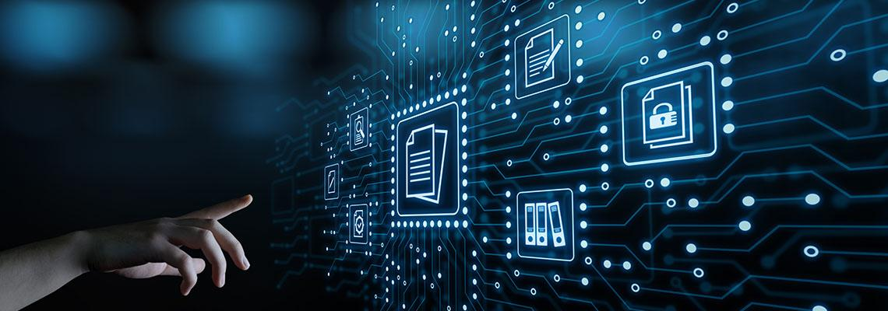

1181228215 / Alexander Supertramp / shutterstock.com

## Types of file locations



248782447 / goodluz / shutterstock.com

In a small business, sensitive files would normally be kept in the location of the businesses data files. Although the location would be the same, the folder structure would differ in having folders with sensitive data being properly secured.

Let us have a look at a few scenarios in ways that a small business stores data, keeping in mind that all business models will normally have 3 options – onsite storage, cloud storage, or a mixture of both.

Learn more about types of file locations:

|  |  |
| --- | --- |
| Micro business with standalone computer  This type of business might be a home-based business that does consultancy work, or a business that has a number of service staff but a single computer that managers and plans all the business activities.  *Data capacity 10GB to 250GB* | The structure of the business could be:   * Bookkeeping application running straight from the vendor's cloud * Client contacts running through cloud-based application such as Microsoft Outlook * File storage can be located on the computer or cloud, or synchronised with the cloud |
| Small network business up to 10 users  This type of business could have a small 5 to 10 user peer-to-peer or server-client network. These types of businesses can range from a small motel complex, retail outlet, small medical clinics, to small engineering firms.  *Data capacity 250GB to 1TB* | The structure of the business could be:   * Bookkeeping application running straight from the vendor's cloud * Client contacts running through cloud-based application such as Microsoft Outlook * File storage can be located on a network attached storage (NAS) device, or server, or cloud, or synchronised with the cloud |

|  |  |
| --- | --- |
| Small network business up to 50 users  This type of business would have a server-client network. These types of businesses can range from a small business with multiple departments, to design centres or application development hubs.  *Data capacity 1TB and above.* | The structure of the business could be:   * Accounting application running straight from the vendor's cloud, or server-based * Client contacts running through a cloud-based or server-based application such as a customer relationship management system * File storage managed through the server via NAS, synchronised with the cloud |

|  |  |
| --- | --- |
| Note-01 | Note |
| As you can see from the above scenarios the way that files can be stored can easily vary. This also means that the way that businesses secure sensitive information will also vary depending on where the information is stored. | |

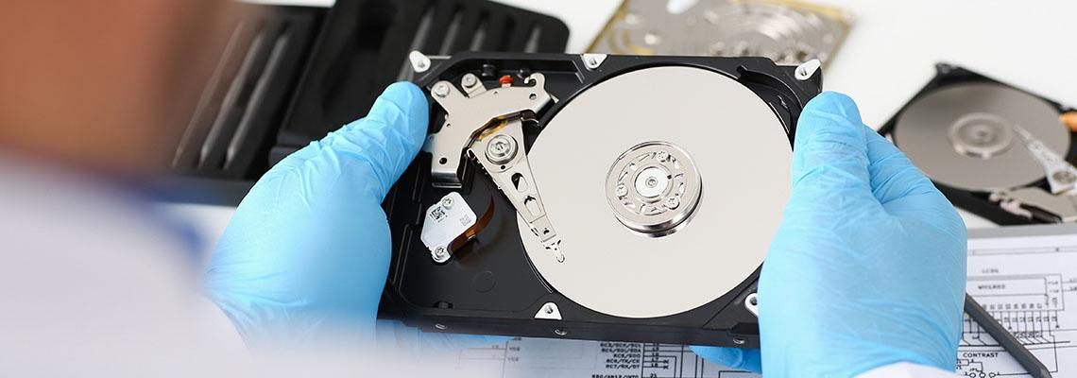

744358555 / H_Ko / shutterstock.com

Less than 10 years ago, a business file storage location would have been on a hard disk drive (HDD). On a standalone system this would be an internal HDD with backups to external USB memory stick, or portable HDD, depending on the amount of data.

A small network (5 computers in a peer-to-peer configuration) would designate one computer as the main file storage device with all other computers having mapped folders linked to them, or a network attached storage (NAS) device and all computers mapped to it.

On a server/client network (domain), the server would have 2 or more HDD installed for the main storage. These drives would be attached to a RAID controller for redundancy and backups would be performed to a tape cartridge drive embedded in the server.

Step forward to today, and businesses have access to the NBN in most places, cloud storage is now becoming more the norm.

|  |  |
| --- | --- |
| Activity-01 | Activity |
| List the different types of storage devices you use for your own data and compare your list with your fellow colleagues. | |

## The Cloud

Cloud computing is a concept that helps organisations to ease the burden of managing IT infrastructure and save money on capital expenditure spent on infrastructure. Today's organisations can implement their complete IT network and run their applications on the cloud.

A simple cloud solution for a micro or small business could be services such as OneDrive. However, for a more secure option it would be preferrable to look at cloud services offered by the numerous vendors currently in the marketplace.

|  |  |
| --- | --- |
| Note-01 | Note |
| For this unit we will be only looking at cloud as a storage service, although the basics will still be covered. | |

Learn more about cloud computing services:

|  |  |
| --- | --- |
| Infrastructure as a service (IaaS) | Hardware based IT resources in a network can be categorised as infrastructure, such as computers (servers), storage, networking resources such as routers and switches. Cloud can host these resources in a virtual environment where consumers can implement their complete network in the cloud which is called Infrastructure as a service.  IaaS offered in cloud is not a pre-configured service; consumers have full control over how they want the network and infrastructure deployed, therefore the responsibility of managing the cloud is placed directly upon cloud consumers. |
| Platform as a service (PaaS) | Platform as a service includes the preconfigured environment of IaaS; cloud consumers only use the service as a platform to run their development tools, use operating systems, and for business analytics.  In this model the burden of infrastructure management is taken away from the consumers who only pay for the platform services they use. |
| Software as a service (SaaS) | Software as a service let consumers use software programs in the cloud without installing them in local computers. SaaS already includes IaaS and PaaS, but consumers only use and pay for SaaS built on IaaS and PaaS.  The best example for SaaS is Microsoft Office 365. Consumers can use the complete Microsoft office package online by subscribing to MS Office 365 and paying a monthly subscription. |

There are three main cloud computing models, distinguished by ownership, size and access. Learn more about these:

|  |  |
| --- | --- |
| Public cloud | Public cloud is hosted by a provider, available to all and connected via an internet connection. Public cloud services are offered to consumers at a cost. The cloud provider is responsible for physical infrastructure and maintenance of their resources.  Consumers need the least technical expertise to use public cloud compared to other cloud computing models. |
| Private cloud | Private cloud is owned and hosted by a private organisation (on-premises), with the purpose of centralising access to different departments or sections of the organisation. The access to private cloud is only for people who have permission. Actual administration of the private cloud could be under internal staff or outsourced company. Private cloud may physically be in the same location, but the cloud services should be available to access remotely to cloud consumers. |
| Hybrid cloud | Hybrid cloud consists of aspects of both private cloud and public cloud. For example, an organisation may have their server running on premises but want to create storage in a cloud that is connected and synchronised to a local server. For another example, an organisation may prefer to store their sensitive data on-premises while running other services on the cloud. The most important configuration concern for hybrid cloud would be that of the integration between public and private cloud. |

|  |  |
| --- | --- |
| Note-01 | Note |
| Each type of cloud offers pros and cons for their type. The public cloud is the cheapest to run as it is an operational expense for a business. It lacks security, but also requires the least amount of IT expertise. Whereas the private cloud can have the highest security, but also requires the highest IT expertise as everything is managed by the business. | |

A simple comparison is given below:

|  |  |  |  |
| --- | --- | --- | --- |
| Feature | Public | Private | Hybrid |
| Expenditure type | Operational | Capital | Both |
| Security | Lowest | Highest | Medium |
| Flexibility | Lowest | Medium | Highest |
| Technical expertise | Least | Most | Medium |

### Cloud computing solutions

|  |  |
| --- | --- |
| Weblink-01 | Weblink |
| These are the top 5 cloud solutions that Australian businesses are increasingly using; all these solutions offer cloud services.  [Amazon Web Services (AWS)](https://aws.amazon.com/)[89]  [Microsoft Azure](https://azure.microsoft.com/en-au/)[90]  [Google Cloud](https://cloud.google.com/)[91]  [Alibaba Cloud](https://au.alibabacloud.com/)[92]  [IBM Cloud](https://www.ibm.com/au-en/cloud)[93] | |

|  |  |
| --- | --- |
| **Discussion-01** | Discuss |
| Out of the above cloud service providers AWS and Azure hold the biggest share of the market.  We will take AWS and Azure as an example when we discuss cloud solutions. | |

|  |  |
| --- | --- |
| Weblink-01 | Weblink |
| Visit this link for [An overview of Azure availability zones and regions[94]](https://docs.microsoft.com/en-us/azure/availability-zones/az-overview)  For information about Azure storage products see:  [Azure Blob storage](https://azure.microsoft.com/en-us/services/storage/blobs/)[95]  [Azure file storage](https://azure.microsoft.com/en-us/services/storage/files/)[96] | |



641066050 / Jirsak / shutterstock.com

## Topic summary and review

This topic covered the knowledge and skills needed to understand the different types of file locations. These locations included the traditional storage devices and the emergence of cloud storage solutions which are becoming an everyday norm.

|  |  |
| --- | --- |
| SelfCheck-01 | Self-check – File location |
| 3 options for file storage are onsite storage, cloud storage, or a mixture of both:   * True * False   Which of the following is not a file storage area?   * HDD * NAS * NVMe * Cloud   Which one of the following is not a cloud service?   * Amazon Web Service * Cumulus cloud * Azure Cloud   *Check your answers at the end of this Learner Guide* | |

# Data integrity and authorised access

## Introduction

So is your data safe, or reliable? This topic looks at understanding your data integrity and how reliable it is, especially when sending the data to someone. The topic will also look at keeping your data safe and secure from malicious players.

### Objectives

By completing this topic, you will be able to do the following:

* Understand attacks on data integrity.
* Know how to mitigate data integrity attacks.
* Allow permission to access data.
* Understand the difference between data encryption and hashing.



256405030 / Imilian / shutterstock.com

## Attacks on data integrity



525451774 / phloxii / shutterstock.com

**What is data integrity?**

Data integrity normally refers to the overall accuracy, completeness, and consistency of data. Therefore, data integrity is a guarantee that the personal information can only be accessed or modified by those who are authorised to do so.

|  |  |
| --- | --- |
| Reading-01 | Reading |
| Visit this link and read **10.1** and **10.2** of the **Australian Privacy principles guidelines**:  [Chapter 10: APP10 – Quality of personal information](https://www.oaic.gov.au/privacy/australian-privacy-principles-guidelines/chapter-10-app-10-quality-of-personal-information)[97] | |

|  |  |
| --- | --- |
| video | Video |
| Watch this video to help you understand more about [confidentiality, integrity and availability of computer security](https://www.youtube.com/embed/j8FT9WqmuDY?rel=0)[98]. | |

|  |  |
| --- | --- |
| Types of attacks | Over time, data has been evolving in the way it is seen in the domain of cyber security. |
| Data availability | When data became easily available it went through the first type of attacks by malware and distributed denial of service (DDOS). Malware has a history preventing access to data, while DDOS attacks the bandwidth or resources of a targeted system. |
| Data confidentiality | Cyber threats to data confidentiality are characterised as data theft. |
| Data integrity | This type of data integrity attack does not deny you access like malware, or steal your data, but it does compromise the integrity of your data concerning accuracy and reliability. |

|  |  |
| --- | --- |
| What is a data integrity attack? | Data integrity is an assurance that the information can only be accessed, or modified, by authorised persons. Therefore, data integrity attack objectives are to compromise this assurance with the intention to gaining unauthorised access with goals to modify data accuracy and reliability.  An example of a data integrity attack occurred in 2016 – Both the World Anti-Doping Agency and Democratic National Committee were breached with hackers manipulating data to embarrass the organisations. These types of attack are the worst modes of cyber-attack because manipulated and modified data can have unintended consequences. Imagine if terrorists modify sensitive military and government data. It can lead to catastrophic consequences. |
| How are data integrity attacks carried out? | Data integrity attacks involve a number of combined attacks on different layers in the system with a purpose to exploit vulnerabilities. Attackers will achieve a level of access based on the level of vulnerabilities. Attackers use a number of tools and techniques to breach and monitor a system over time. Attackers will sometimes imbed their bugs into the infrastructure and wait for years until they think it is the perfect time to attack.  Consider a scenario in which the attacker plants malware through phishing emails in the administrator's computer. The malware establishes a key logger program in the system to gain the credentials. In the meantime, he can also change the security settings and infiltrate more harmful programs. This is the way integrity attacks occur. These attacks are very dangerous and have the potential to conquer the whole system. |

|  |  |
| --- | --- |
| video | Video |
| Watch this video to help you learn more about mitigating [cyber-attacks](https://www.youtube.com/embed/N68pGHbnJWc?rel=0)[99]. | |

## Mitigating data integrity attacks

|  |  |
| --- | --- |
| Tip-01 | Tip |
| **How can these attacks be prevented?**  Implementing certain security measures, can help prevent data integrity attacks. Most attacks target the networks and then they climb up the ladder as each level of vulnerability is breached. | |

### Compatibility Mode:

The majority of breaches occur internally, via devices and email. If staff members use USB memory sticks to transfer data between their home computer and the office network, malicious data may be transferred. Staff should therefore use cloud-based storage and move away from using such devices.

On larger networks, constructing separate networks in the system will help stop spreading attacks. Using security suites in all devices will act as a shield from integrity attacks. In order to detect and prevent data integrity attacks, we must also consider developing network security tools with artificial intelligence, which can block suspicious moves.

Staff members may be enticed to click on “phishing” emails with attachments, or links that promise prizes or other incentives. This is best prevented by providing quality training for staff, in how to identify and avoid such threats.

The implementation of strong password policies and using 2 points of verification for access to secured personal information is necessary in any situation where privacy of information is concerned. All this is useless if training of staff is not provided to a level where the staff can recognise possible threats and social engineering traits.

|  |  |
| --- | --- |
| video | Video |
| For more on this topic, watch this video [Cyber Threats & Safeguards to Protect you against Attacks](https://www.youtube.com/embed/Z-0ZphHmQDE?rel=0)[100]. | |

## Authorised personnel

|  |  |
| --- | --- |
| Tip-01 | Tip |
| The Collins Dictionary defines "authorised" as officially permitted or empowered. | |

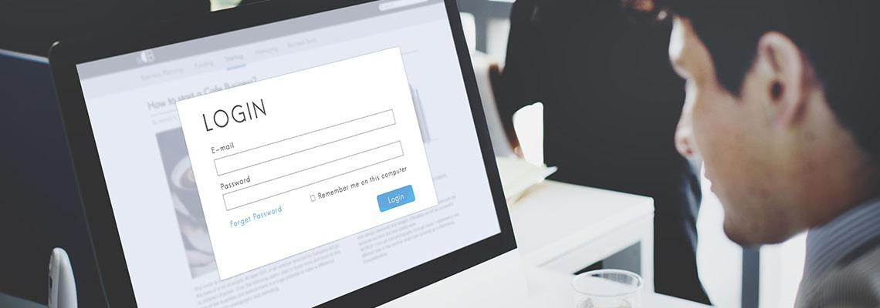

1404797651 / Rawpixel.com / stock.adobe.com

People who are authorised to access sensitive personal information should be properly trained in privacy rights, and how to identify common threats.

Authorised personnel should have a good understanding of the Privacy Act and prior to accessing personal information sign a form indicating the policy and procedures set out in the Privacy Act 1988 and the organisation's policies.

An authorised person having access to personal information should have knowledge of:

* *principles of the Privacy Act 1988* principles of the Privacy Act 1988
* *data protection and encryption* data protection and encryption
* *how to recognise and action phishing emails* how to recognise and action phishing emails
* how to identify changes in systems and programs that indicate malicious intrusion.

|  |  |
| --- | --- |
| Note-01 | Note |
| The above should be part of induction for new employees with a signed employment agreement. | |

|  |  |
| --- | --- |
| video | Video |
| To learn more watch the following video [Privacy and data protection](https://www.youtube.com/embed/ZNEPaGFApX4?rel=0)[101] | |

## Access permissions

There are means of enforcing access permissions such as password access and implementing two-factor authentication, regardless of whether the computer system is standalone or a domain-based client-server network.

Learn more about using access permissions:

|  |  |
| --- | --- |
| Enforce password access | On any system the most basic access permission is to enforce passwords for all users. This means that when a person starts a computer on whatever system they use, the first thing that occurs is the user requires a username and password to logon. Review the previously covered topic of creating strong passwords. |
| Two-factor authentication | Two-factor authentication (2FA) is where you will logon to a system, or gain access to an application, using two forms of verification. This is done using something you know, such as your password, and something you have, such as a mobile phone.  Two-factor authentication acts as a second line of defence because if your password is guessed by a hacker sensitive personal information becomes vulnerable to malicious intent. Two-factor authentication attempts to tackle that flaw by requiring a secondary code called a one-time password (OTP). OTPs are usually six characters in length and are produced by a smartphone app before you can gain access to your account. So, if a hacker has your password, they will still need to break a secondary code, which makes getting into the system much more difficult.  There are numerous apps that are now available to setup two-factor authentication, depending on the systems you are using. Two of the largest companies in the IT space, Google and Microsoft both have apps available, as do many other companies in the marketplace. |
| Training | Passwords and 2FA are never fun things to enforce with staff, as some will respond with "not more passwords". However, good training should explain why strong passwords and 2FA are essential. The more information provided to staff on the effects of sensitive data being breached, the better will be staff understanding of the perhaps devastating consequences. |

|  |  |
| --- | --- |
| DidYouKnow-01 | Did you know? |
| Two-factor authentication as a software application is not the only way two-factor authentication can be implemented. It also can be achieved by hardware.  The safest way to lock down your accounts with two-factor authentication is to employ a physical security key. It has been found in studies that security keys blocked 100 percent of bulk phishing and targeted attacks.  But where there is a positive there is normally a negative. The negative of using a security key is that if you ever break or lose the key you could be locked out of your system. You will then have to change your second-factor authentication method to a new key. | |

|  |  |
| --- | --- |
| video | Video |
| Watch these videos to help you understand more about [two-factor authentication](https://www.youtube.com/embed/videoseries?list=PLr24-CFnxcCxVlG5-YzwseMCR-W-c_xaw)[102].  There are two videos in this playlist. Please use the playlist menu button in the top right corner to view all videos in this playlist. | |

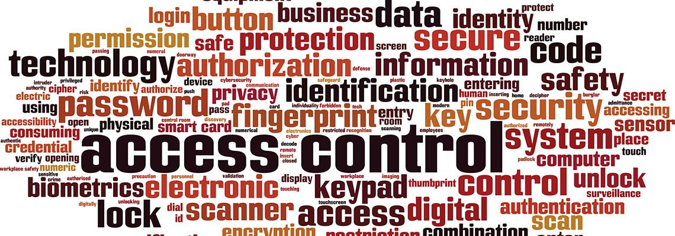

1465537388 / Boris15 / shutterstock.com

## Encryption

### Why is encryption important?

The reason for file and hard disk encryption is to safeguard data stored on a device such as a computer, or any type of network storage device. Organisations, including micro and small businesses, which collect personal or sensitive information must secure that data. An organisation can suffer fines for individuals and the organisation itself if breaches occur.

If a laptop is stolen, or maybe lost, and the files or hard drive is not encrypted, that information can be accessed and used for malicious purposes. It is good business practice to encrypt your sensitive information, if not your entire hard drive.

Disk encryption does not offer full protection of a computer system. The computer can still be accessed by a hacker over an insecure network connection, or if a user clicks on a malicious link that they receive in an email. This could then infect the computer with malware that steals usernames and passwords. These types of attacks require additional security controls, this would include:

* security software for malware
* firewalls
* staff awareness training.

Nevertheless, encrypting a computer's files or the entire hard drive significantly reduces the risk of data theft.

|  |  |
| --- | --- |
| video | Video |
| Learn more about [encryption](https://www.youtube.com/embed/dut9EnbFym0)[103] by watching this video. | |

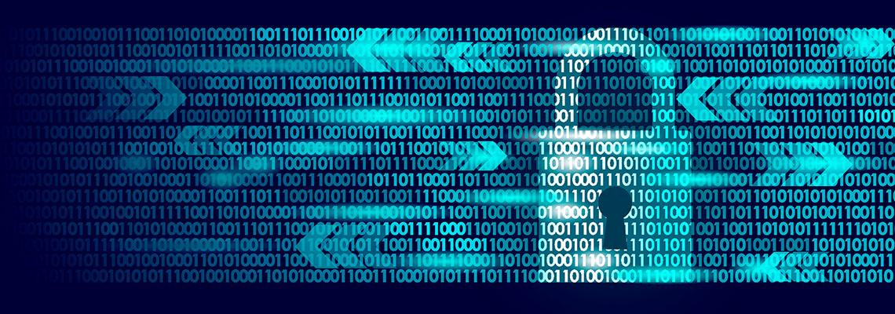

1040601754 / LuckyStep / shutterstock.com

## Encrypting files

|  |  |
| --- | --- |
| Tip-01 | Tip |
| All modern-day operating systems will have some support for encrypting files. You can also use utilities, such as WinZip, to encrypt your files. | |

Learn more about encrypting files:

|  |  |
| --- | --- |
| In Microsoft Windows:   * Right click on a file or folder and select Properties. * Select the Advanced button and select the Encrypt contents to secure data check box * Select OK to close the Advanced Attributes window, select Apply, and then select OK. | 1042282198 / Elenstone / shutterstock.com |
| To encrypt a folder:   * Create a folder you would like to encrypt. * Go to Disk Utility. * Click File > New Image > Image from Folder. * Find and click on the folder you created. * Select an encryption method, create a password, and save your encrypted folder. | A group of colorful folders  Description automatically generated with low confidence  214094713 / Mtsaride / shutterstock.com |

|  |  |
| --- | --- |
| To encrypt in a Linux-based operating system, such as Ubuntu:   * Right-click on a file or folder and select Encrypt. * Select to use a shared passphrase or create or import a key.   Once you have gone through the process of a passphrase or key, and if you are encrypting a folder, you will be asked if you want to encrypt each file contained within or pack them together in a compressed file. | 549647422 / sakkmesterke / shutterstock.com |

|  |  |
| --- | --- |
| video | Video |
| These videos will help you learn more about [file or folder encryption](https://www.youtube.com/embed/videoseries?list=PLr24-CFnxcCz-fnhenInNKkumrE8w6t3z)[104] in Windows 10, MacOS, and Ubuntu.  There are three videos in this playlist. Please use the playlist menu button in the top right corner to view all videos in this playlist. | |

## Encrypting hard drive

|  |  |
| --- | --- |
| Tip-01 | Tip |
| **Microsoft Windows**  Encryption helps protect the data on your device; this will allow people who have authorisation to access it. If device encryption is not available on your device, you might be able to turn on standard BitLocker encryption instead. Note that BitLocker is not available on Windows 10 Home edition. | |

Learn more about turning on encryption:

|  |  |
| --- | --- |
| Turn on device encryption | 1. Sign into Windows with an administrator account (you may have to sign out and back in to switch accounts). For more info, see Create a local or administrator account in Windows 10. 2. Select the **Start** button, then select **Settings,** then select **Update & Security** , select **Device encryption**.   If **Device encryption** does not appear, it is not available. You may be able to use standard BitLocker encryption instead.  Open Device encryption setting.   * If device encryption is turned off, select **Turn on** |
| Turn on standard BitLocker encryption | * Sign into your Windows device with an administrator account (you may have to sign out and back in to switch accounts). For more info, see Create a local or administrator account in Windows 10. * In the search box on the taskbar, type Manage BitLocker and then select it from the list of results. Or you can select the Start button, and then under Windows System , select Control Panel. In Control Panel , select System and Security , and then under BitLocker Drive Encryption , select Manage BitLocker.   **Note:** You will only see this option if BitLocker is available for your device. It is not available on Windows 10 Home edition.   * Select Turn on BitLocker and then follow the instructions. |

|  |  |
| --- | --- |
| Mac OS X Lion or later | When FileVault is turned on, your Mac always requires that you log in with your account password.   * Choose Apple menu and select System Preferences , then select Security & Privacy. * Click the FileVault tab. * Click Locked , then enter an administrator name and password. * Click Turn On FileVault. |
| Linux OS | Most Linux operating systems do not allow for an easy encryption of a hard drive after the initial installation process is complete. The option to encrypt is selected during the steps of the operating system install.  There are optional workarounds; however, it is considered easier to back up your data and re-install the operating system from scratch. |

|  |  |
| --- | --- |
| video | Video |
| Watch these videos to learn more about [encrypting your hard drive](https://www.youtube.com/embed/videoseries?list=PLr24-CFnxcCzpc0SR93C6EFGu0XOjP-sP) [105] in Windows 10 and using FileVault to secure your data in Mac10.  There are two videos in this playlist. Please use the playlist menu button in the top right corner to view all videos in this playlist. | |

## Hashing



1117603757 / Trikona / shutterstock.com

Hashing is used to verify data integrity; it is not encryption.

Hashing is achieved by having an algorithm performed on data, such as a file or message, to create a number called a hash (also known as a checksum). The hash is then used to validate that the data has not been modified, tampered with, or corrupted. This is where you can verify the data has maintained integrity.

Integrity of the data is directly linked to the hashing algorithm, if the hash differs at any point, it means that the data has been modified or corrupted.

|  |  |
| --- | --- |
| Example-01 | Example |
| An IT technician has to update the BIOS on a computer system. When running the actual update to the ROM (Read Only Memory) it applies the data in sections and compares the section that was just updated with the checksum, which is the hash.  If the checksum differs, it then reapplies the section again just in case it was a packet of data that did not transfer over properly. If the checksum fails again, the whole process is stopped, and the BIOS returned to its original condition.  The hash checks that the data applied to the ROM is exactly the data supplied by the creator, therefore establishing data integrity. | |

|  |  |
| --- | --- |
| video | Video |
| Watch these videos to learn more about [hashing](https://www.youtube.com/embed/videoseries?list=PLr24-CFnxcCwFb5m3WxbrNlzCojnsKQ1i)[106].  There are two videos in this playlist. Please use the playlist menu button in the top right corner to view all videos in this playlist. | |

## Hashing algorithms and files

### Hashing files

Numerous applications calculate and compare hashes automatically, this normally occurs without any user involvement. An example is where a digital signature uses a hash within an email, and email applications automatically create and compare the hashes.

Additionally, there are a number of applications you can use to manually calculate hashes.

As an example, the Microsoft Store has a tool developed by DigitalVolcano Software called **Hash Tool** , which is a free program anyone can use to create hashes of files.

A Google search on "hash tool download" will show a list of applications that are available.  
Some of the common hashing algorithms in use today are:

|  |  |
| --- | --- |
| MD5 | Message Digest 5 (MD5) is a common hashing algorithm that produces a 128-bithash. Hashes are commonly shown in hexadecimal format instead of a stream of 1s and 0s. For example, an MD5 hash is displayed as 32 hexadecimal characters instead of 128 bits. Hexadecimal characters are composed of 4 bits and use the numbers 0 through 9 and the characters a through f. |
| SHA | Secure Hash Algorithm (SHA) is another hashing algorithm. There are several variations of SHA grouped into four families—SHA-0, SHA-1, SHA-2, and SHA-3:   * SHA-0 is not used. * SHA-1 is an updated version that creates 160-bit hashes. This is similar to the MD5 hash except that it creates 160-bit hashes instead of 128-bit hashes. * SHA-2 improved SHA-1 to overcome potential weaknesses. It includes four versions. SHA-256 creates 256-bit hashes and SHA-512 creates 512-bit hashes. SHA-224 (224-bit hashes) and SHA-384 (384-bit hashes) create truncated versions of SHA-256 and SHA- 512, respectively.   SHA-3 (previously known as Keccak) is an alternative to SHA-2. The S. National Security Agency (NSA) created SHA-1 and SHA-2. SHA-3 was created outside of the NSA and was selected in a non-NSA public competition. It can create hashes of the same size as SHA-2 (224 bits, 256 bits, 384 bits, and 512 bits). |
| HMAC | Another method used to provide integrity is with a Hash-based Message Authentication Code (HMAC). An HMAC is a fixed-length string of bits similar to other hashing algorithms such as MD5 and SHA-1 (known as HMAC-MD5 and HMAC-SHA1). However, HMAC also uses a shared secret key to add some randomness to the result and only the sender and receiver know the secret key. |

|  |  |
| --- | --- |
| RIPEMD | RACE Integrity Primitives Evaluation Message Digest (RIPEMD) is another hash function used for integrity. It is not as widely used as MD5, SHA, and HMAC. |

|  |  |
| --- | --- |
| Tip-01 | Tip |
| It is worth emphasising that hashes are a one-way function. You can calculate a hash on a file or a message, but you cannot use the hash to reproduce the original information. Also, to note, the hash code will always be the same length, no matter how big the file is. | |

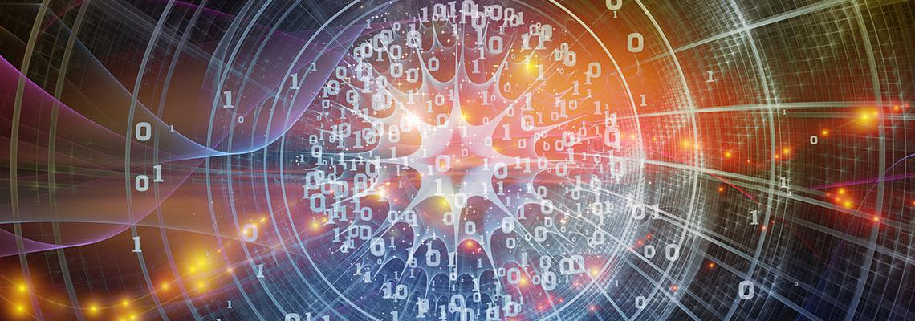

1383333578 / agsandrew / shutterstock.com

## Hashing messages

|  |  |
| --- | --- |
| Tip-01 | Tip |
| For integrity when sending messages, hashing is a good option. Hashing will provide a guarantee to a person receiving a message that the message has not been altered or modified. | |

|  |  |
| --- | --- |
| Scenario-01 | Scenario |
| 1369435550 / tadamichi / shutterstock.com  If we look at a scenario where Bill is sending a message to Ted. The message is "The song is almost complete." As this message may not be secret, there is no need to encrypt it. Although, we do want to establish integrity, so the focus on this description is only on hashing.  In this scenario, something modified the message before it reaches Ted. When Ted receives the message and the original hash, the message is now "The song is nearly almost complete." | |

|  |
| --- |
| It shows that the message has been modified in transit, but the hash has not changed. A program on Ted's computer calculates the MD5 hash on the received message as 564294439E1617F5628A3E3EB75643FE. It then compares the received hash with the calculated hash:   * Hash created on Bill's computer, and received by Ted's computer: D9B93C99B62646ABD06C887039053F56 * Hash created on Ted's computer: 564294439E1617F5628A3E3EB75643FE   The above shows that the hashes are different, so it indicates that the message has lost integrity. The program on Ted's computer would report the discrepancy.  This shows that there could have been a malicious attacker modifying the message, or it could have been a technical problem. However, Ted is now aware that the received message is not the same as the sent message and he should not trust it. |

|  |  |
| --- | --- |
| Activity-01 | Activity |
| Download a hashing algorithms application to your system.  Copy a number of files to a temporary folder and create a hash for the file.  Compare the hash and see if there is any correlation between each created hash. | |

## Topic summary and review

This topic covered the knowledge and skills needed to understand data integrity, the attacks on data integrity, and how to mitigate these attacks. The topic also covered permission to access data and understanding the difference between data encryption and hashing.

|  |  |
| --- | --- |
| SelfCheck-01 | Self-check – Data integrity and authorised access |
| Which of the following is not a hashing algorithm? Select the correct response:   * MD5 * PC-7 * SHA * HMAC   If laptop is stolen, or maybe lost, and the files or hard drive is not encrypted, anyone can access any sensitive information.   * True * False   Two-factor authentication (2FA) is where you will logon to a system, or gain access to an application, using two forms of verification. The first factor is something you know, such as your password and the other is something you have, which is.......? Select the correct response:   * An asset such as a car or house * A device such as a mobile phone * Knowledge, such as training or experience   *Check your answers at the end of this Learner Guide* | |

# Destroying data

## Introduction

So let us delete the data. Clicking the delete does not meet the requirements for sensitive personal data. This topic looks at how an organisation retains sensitive information and what steps are required to destroy the data or records. At no point does an organisation want to be the next headline in the news because someone found other people's personal information sitting in a garbage bin.

### Objectives

By completing this topic, you will be able to do the following:

* Understand the retention of data or records.
* Understand Queensland Government agencies' destruction of data procedures.
* Understand Queensland Government agencies' documentation.
* Understand destruction of data procedure for non-government organisations.



518466241 / Photobank.kiev.ua / shutterstock.com

## Retention of data or records

There are a number of laws that come into effect in regard to the length of time records are kept and the way they are destroyed. In this section, when we use the wording "records" it refers to the same meaning as data but can be in hard copy as in printed material and stored or archived in a physical filing system.

|  |  |
| --- | --- |
| Tip-01 | Tip |
| **Retention of records**  To give a better understanding of the destruction of records in an organisation, it is also good to understand how long the organisation must retain the records before destroying them. | |

**Common Law**

The general position in common law is that an organisation's documents are the property of that organisation and they can deal with them anyway they want. The exceptions start to arise in regard to a number of federal and state legislations. Learn more below:

|  |  |
| --- | --- |
| The Income Tax Assessment Act (1936) (Cth) | This Act requires that organisations carrying on a business keep hold of records relevant to the organisation's income and expenditure for at least 5 years. |
| The Fair Work Act 2009 (Cth) | Requires that employee records be retained for a minimum of 7 years from the end of the financial year in which the document was created. The scope of 'employee records' is broad, and includes information such as the employment, training, discipline, performance, behaviour, and termination of the employee, as well as the employee's terms and conditions of employment, income, taxation elements and entitlements. |
| The National Privacy Principles (NPPs) | Also impact an organisation's records retention and destruction policies, as organisations subject to the NPPs must destroy or de-identify records containing personal and sensitive information if the organisation no longer needs information for the purpose for which it was collected, or for any purpose for which it may be used or disclosed. |
| The Privacy (Tax File Number) Rule 2015 [4] | Also requires organisations to take practical steps to securely destroy or permanently de-identify tax file number information that is no longer required by law to be retained or is no longer required for a purpose under taxation law, personal assistance law or superannuation law. |
| The Corporations Act 2001 (Cth) | Also contains various document retention requirements including financial records for at least seven years, and organisational records such as meeting minutes and registries for at least five years. |

## Destruction of data – Queensland government agencies

The destruction and transfer of public records must have authorisation from the State Archivist. You can usually get this authorisation through a retention and disposal schedule. Sometimes authorisation may be provided through another legal authority.

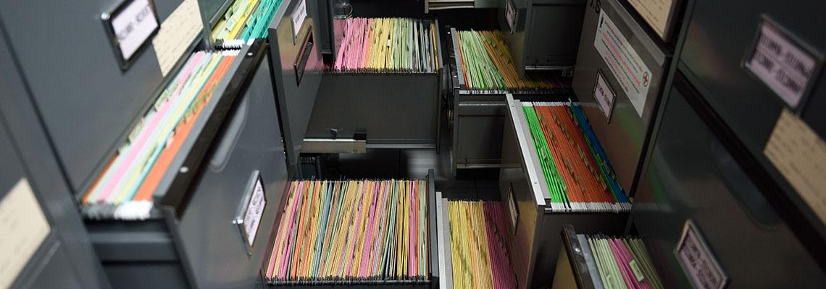

300735176 / Nirat.pix / shutterstock.com

You also cannot sell, donate, abandon, damage, or amend a record without authorisation.

|  |  |
| --- | --- |
| Weblink-01 | Weblink |
| Visit this web page for [detailed information about government agency destruction and disposal of data](https://www.forgov.qld.gov.au/information-and-communication-technology/recordkeeping-and-information-management/recordkeeping/retention-disposal-and-destruction-of-records/how-to-destroy-records).[107] Destruction of government agency records must also be recorded. You will also find more information about documenting the destruction of records using this same link. | |

### Choose the best method

The method of sanitisation necessary to appropriately destroy digital public records will depend on the data's sensitivity and the type of storage media.

|  |  |  |  |
| --- | --- | --- | --- |
| Media/device | Non-sensitive | Moderately sensitive | Highly sensitive |
| Hard disk drive | Overwriting  Purging  Physical destruction | Purging  Physical destruction | Physical destruction |
| Magnetic tape | Overwriting  Degaussing  Physical destruction | Degaussing  Physical destruction | Physical destruction |
| Floppy disk | Overwriting  Degaussing  Shredding  Physical destruction | Degaussing  Shredding  Physical destruction | Physical destruction |

|  |  |  |  |
| --- | --- | --- | --- |
| CD/DVD | Shredding  Physical destruction | Shredding  Physical destruction | Physical destruction |
| SSD  USB memory stick  Memory cards  Flash drives etc. | Overwriting  Purging  Physical destruction | Overwriting  Purging  Physical destruction | Physical destruction |
| Mobile phone / PDA | Purging  Physical destruction | Purging  Physical destruction | Physical destruction |
| Hybrid device | Overwriting  Physical destruction | Overwriting  Physical destruction | Physical destruction |
| Faulty, unreadable, or unusable media or devices, or where sanitisation fails | Physical destruction | Physical destruction | Physical destruction |
| ROM | Physical destruction | Physical destruction | Physical destruction |
| PROM | Physical destruction | Physical destruction | Physical destruction |
| EPROM | Manufacturer specification for ultraviolet erasure time is multiplied by 3 to ensure data is irretrievable | Manufacturer specification for ultraviolet erasure time is multiplied by 3 to ensure data is irretrievable | Manufacturer specification for ultraviolet erasure time is multiplied by 3 to ensure data is irretrievable |
| EEPROM | A single overwrite with random data | A single overwrite with random data | A single overwrite with random data |

© The State of Queensland 2021, How to destroy records (11/01/22. CC BY 4.0

|  |  |
| --- | --- |
| Note-01 | Note |
| Even if using a commercial destruction service, your agency is still responsible for ensuring that the records are securely stored, transported and destroyed as soon as possible after their arrival at the destruction site. | |

## Destruction of data – non-government organisations

Non-government entities under the Australian Privacy Principles, must actively ensure the security of any personal information that it holds. This includes the considered destruction and disposal of records that are no longer needed for the original purpose of collection.

|  |  |
| --- | --- |
|  | Weblink |
| For detailed information on this topic see [Chapter 11: APP 11 — Security of personal information](https://www.oaic.gov.au/privacy/australian-privacy-principles-guidelines/chapter-11-app-11-security-of-personal-information)[108] Also, for information about media sanitisation and/or destruction, see the ACSC page [Guidelines for media[109]](https://www.cyber.gov.au/acsc/view-all-content/advice/guidelines-media) | |



1925795873 / Evgeny Ostroushko / shutterstock.com

## Topic summary and review

This topic covered the knowledge and understanding for the retention of data or records, and how organisations destroy data or records.

|  |  |
| --- | --- |
| SelfCheck-01 | Self-check – Destruction of data |
| Which of the following two (2) devices must be physically destroyed if they hold sensitive data?   * HDD * SATA cable * DVD * Projector   All Queensland Government agencies must obtain authorisation from the State Archivist when destroying data.   * True * False   The ‘reasonable steps’ an organisation should take to destroy sensitive data depend upon circumstances that include? Select the correct response.   * the amount and sensitivity of the personal information * the time available to destroy the sensitive data authorisation from shareholders * authorisation from shareholders   *Check your answers at the end of this Learner Guide* | |

# Privacy Impact Assessment

## Introduction

In this last topic for the unit will be looking more closely at the effect of an organisation's project on the privacy of personal information and the steps required to assess impact.

### Objectives

By completing this topic, you will be able to do the following:

* Undertake a privacy impact assessment.
* Understand how to do a privacy impact statement.

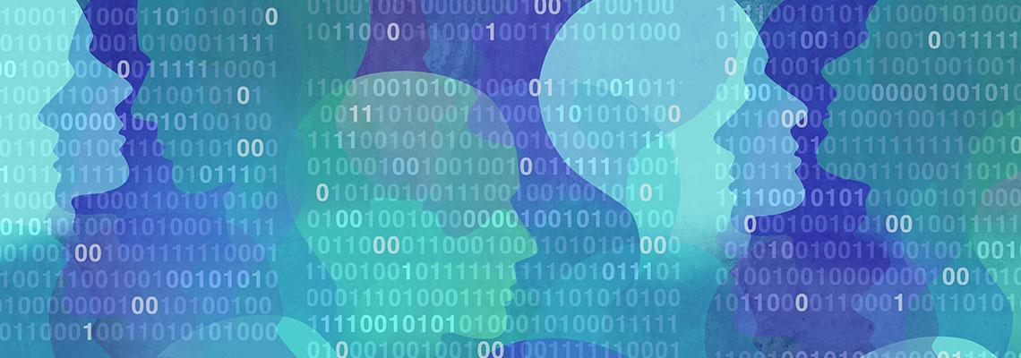

1062285074 / Lightspring / shutterstock.com

## Undertaking a Privacy Impact Assessment

**Why undertake a PIA?**

Although it is not mandatory to conducting a PIA, it is strongly advised. Doing so will assess whether a project complies with the Information Privacy Act 2009 (Qld) (IP Act) and will assist with governance in terms of making informed decisions.

The PIA should enable the early identification of likely problems, so these can be addressed sooner rather than later, when it may be more costly to deal with them.

The PIA will highlight and mitigate any issues of community mistrust in the agency's processes of information handling.

|  |  |
| --- | --- |
| Tip-01 | Tip |
| The PIA should occur in the first stage of development of a project, so that discoveries can "influence the design of the project", mitigating the effect of expending time and resources on options that do not comply with the IP Act.  It's a good idea to account for necessary changes as issues are identified during the PIA. The OAIC suggests building "PIA checkpoints" into the project plan. | |

|  |  |
| --- | --- |
| Weblink-01 | Weblink |
| For more details see [Undertaking a Privacy Impact Assessment[110]](https://www.oic.qld.gov.au/guidelines/for-government/guidelines-privacy-principles/privacy-compliance/overview-privacy-impact-assessment-process/undertaking-a-privacy-impact-assessment) | |



1082723480 / Olivier Le Moal / shutterstock.com

## How to conduct a Privacy Impact Statement

|  |  |
| --- | --- |
| Weblink-01 | Weblink |
| **OAIC resources**  The [OAIC website[111]](https://www.oaic.gov.au/) provides detailed advice and guidance to undertaking a Privacy Impact Assessment.  Please visit and read [Undertaking Privacy Assessments](https://www.oaic.gov.au/privacy/guidance-and-advice/guide-to-undertaking-privacy-impact-assessments).[112]  See also [the Privacy Management Plan Template (for organisations)[113]](https://www.oaic.gov.au/privacy/guidance-and-advice/privacy-management-plan-template-for-organisations)  Download/view the OAIC's free [printable poster which provides a step-by-step guide[114]](https://www.oaic.gov.au/privacy/guidance-and-advice/10-steps-to-undertaking-a-privacy-impact-assessment-poster) to undertaking a Privacy Impact Assessment or go to Appendix A at the end of this Learner Guide to view in full. | |

# Self-check answers

|  |  |
| --- | --- |
| SelfCheck-01 | Self-check – Cyber security for business |
| For most people the passphrase "5paghetti!95" is ?  *Choose the correct response.*   * Easy to remember * Somewhat easy to remember * Very difficult to remember   Which of the following reasons is why you should do software updates?   * Allows better access from outside to network for any person * Enhanced features and efficiencies for programs and apps * Gives full administration to any user on the domain   ACSC is an acronym for the ? *Choose the correct response:*   * Australian Cyber Security Centre * Australasian Cyber Security Centre * Australian Cyber Security Community | |

|  |  |
| --- | --- |
| SelfCheck-01 | Self-check – Securing business tools |
| One of the precautions when accessing the internet at a public Wi-Fi location, is to  ?  *Choose the correct response:*   * Disable the firewall to allow easier access * Make sure no one can see your screen * Ensure the phone, tablet or laptop has a reputable anti-virus installed | |

|  |  |
| --- | --- |
| SelfCheck-01 | Self-check – Legislation standards and policies |
| In what year was the Privacy Act enacted   * 1984 * 1988 * 1996   The Queensland Information Privacy Act 2009 covers all businesses in Queensland   * True * False   What ISO 27001 standard includes the appraisal and management of information security risks:   * ISO/IEC 27001:2013 * ISO/IEC 27001:2015 * ISO/IEC 27002:2013 | |

|  |  |
| --- | --- |
| SelfCheck-01 | Self-check – Company policies |
| The Privacy Act allows an individual to ? Select the correct response:   * have the option of not identifying yourself, or of using a pseudonym in certain circumstances * ask for access to your personal information (including your health information) * stop receiving unwanted direct marketing * all the above   A privacy policy could also be known as a responsible use of data policy   * True * False | |

|  |
| --- |
| The Office of the Australian Information Commissioner has released a guide for securing personal information called?   * Guide to securing personal information - ‘Reasonable steps’ to protect personal information” * Guide to securing personal information - ‘The step-by-step to protect personal information” * Guide to securing personal information - ‘Nearly all steps’ to protect personal information” |

|  |  |
| --- | --- |
| SelfCheck-01 | Self-check - Data |
| Types of personal information can include ‘health information’, ‘credit information’, and ‘tax file number information’.   * True * False   Which one of the following is defined in the Privacy Act as sensitive information?   * Sports club membership * Racial or ethnic origin * Opinion of the best NRL team | |

|  |  |
| --- | --- |
| SelfCheck-01 | Self-check – Sending and receiving sensitive data |
| Under APP 11.2, APP entities must also take reasonable steps to destroy or de-identify the personal information they hold once it is no longer needed:   * True * False | |

|  |
| --- |
| Under APP 3, you should only collect personal information that is reasonably necessary to carry out your functions or activities.   * True * False   Which one of the following is true in regard to emailing sensitive information?   * Use non-encryption messaging for speed and accuracy * Obtain a recipient’s consent to send their own personal information to them via email * Send the email addressed to the recipient and resend the unencrypted email if unsuccessful |

|  |  |
| --- | --- |
| SelfCheck-01 | Self-check – Data integrity and authorised access |
| Which of the following is not a hashing algorithm? Select the correct response:   * MD5 * PC-7 * SHA * HMAC   If laptop is stolen, or maybe lost, and the files or hard drive is not encrypted, anyone can access any sensitive information.   * True * False   Two-factor authentication (2FA) is where you will logon to a system, or gain access to an application, using two forms of verification. The first factor is something you know, such as your password and the other is something you have, which is.......? Select the correct response:   * An asset such as a car or house * A device such as a mobile phone * Knowledge, such as training or experience | |

|  |  |
| --- | --- |
| SelfCheck-01 | Self-check – Destruction of data |
| Which of the following two (2) devices must be physically destroyed if they hold sensitive data?   * HDD * SATA cable * DVD * Projector   All Queensland Government agencies must obtain authorisation from the State Archivist when destroying data.   * True * False   The ‘reasonable steps’ an organisation should take to destroy sensitive data depend upon circumstances that include? Select the correct response.   * the amount and sensitivity of the personal information * the time available to destroy the sensitive data authorisation from shareholders * authorisation from shareholders | |

|  |
| --- |
| One way for staff to protect themselves from malicious emails, is that the staff should not ?  *Choose correct response:*   * be suspicious of messages that aren’t addressed directly to the staff member * think carefully before clicking on links or opening attachments * open messages if you don’t know the sender   WSUS is an acronym for? Choose the correct response:   * Windows System Update Services * Windows Server Update Services * Wally Smith Uber Service |

|  |  |
| --- | --- |
| SelfCheck-01 | Self-check – Business recovery |
| When should you NOT use ReportCyber? Choose the correct response:   * You have been deceived into sending money or goods to someone online. * Someone is bullying, harassing, or stalking you online. * You have received a scam call and no loss of personal information or money has occurred.   What is one of the reasons you would perform backups in a business? Choose the correct response:   * No reason, just everyone tells you that you have to do it. * Offers peace of mind and makes it faster and easier to get up and running again. * Allows employment of an IT technician   Which one of the following would not be part of a backup policy? Choose the correct response:   * How much should be spent on backup media. * The frequency of backups. * Where backups should be stored. | |

|  |  |
| --- | --- |
| SelfCheck-01 | Self-check – Cyber security large organisations |
| The Strategies to Mitigate Cyber Security Incidents – Mitigation Details document provided by ACSC helps organisations mitigate cyber security incidents caused by which two (2) listed below? *Choose two correct responses*:   * Ransomware denying access to data for monetary gain. * Junk emails from their competitors. * Corrupt software updates. * Malicious insiders who destroy data   The ACSC does not offer which Critical Infrastructure support? Choose the correct response:   * Technical expertise in Information and Operational Technologies * Principles-based advice tailored toward high-risk environments * Australian Computer Society   The acronym for ISM stands for ? *Choose the correct response*:   * Information Systems Manual. * Information Security Manual. * Infrastructure Security Manual. | |

# References

Cyber Security Centre 2020, *About small and medium business* ,

https://www.cyber.gov.au/acsc/small-and-medium-businesses/about-this-section, viewed 09/09/2021

ISMS.online, ISO 27001 – *Annex A.8: Asset Management* ,

https://www.isms.online/iso-27001/annex-a-8-asset-management/ , viewed 07/05/2021

Office of the Australian Information Commissioner, https://www.oic.qld.gov.au/ , viewed 11/01/2022.

# Appendix A – Privacy impact assessment

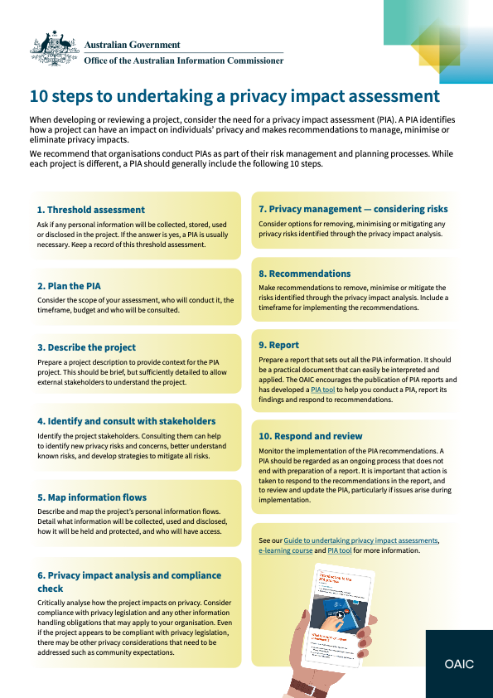

1. http://tafeqld.edu.au/current-students/student-rules/
2. https://www.cyber.gov.au/acsc/small-and-medium-businesses/about-this-section
3. https://www.cyber.gov.au
4. https://www.youtube.com/embed/QozdEbyMK5E?rel=0
5. https://www.cyber.gov.au/sites/default/files/2021-02/ACSC%20Small%20Business%20Cyber%20Security%20Guide.pdf
6. https://docs.microsoft.com/en-us/windows/deployment/update/waas-manage-updates-wsus
7. https://www.youtube.com/embed/0QNRtXFw8v8?rel=0
8. https://www.cyber.gov.au/acsc/view-all-content/guidance/updates-android
9. https://www.cyber.gov.au/acsc/view-all-content/guidance/updates-apple
10. https://www.cyber.gov.au/acsc/view-all-content/guidance/turning-automatic-updates-imac-macbook-iphone-ipad
11. https://www.cyber.gov.au/acsc/view-all-content/guidance/updates-windows-pc-and-mobile
12. https://www.cyber.gov.au/acsc/view-all-content/guidance/turning-automatic-updates-microsoft-windows-10
13. https://www.cyber.gov.au/sites/default/files/2020-11/Step%20by%20Step%20Guide%20-%20Turning%20on%20automatic%20updates%20for%20Mac.pdf
14. https://www.cyber.gov.au/sites/default/files/2021-05/Step%20by%20Step%20Guide%20-%20Turning%20on%20automatic%20updates%20for%20Windows%20-%2020210321.pdf
15. https://www.youtube.com/embed/videoseries?list=PLr24-CFnxcCwRs4TSkbOykPZDNeG5lMJ8
16. https://www.cyber.gov.au/sites/default/files/2021-07/ACSC%20Step%20by%20Step%20Guide%20-%20Email%20Security%20Outlook.pdf
17. https://www.cyber.gov.au/sites/default/files/2021-07/ACSC%20Step%20by%20Step%20Guide%20-%20Email%20Security%20Gmail.pdf
18. https://www.cyber.gov.au/acsc/view-all-content/publications/travelling-overseas-electronic-devices
19. https://www.cyber.gov.au/sites/default/files/2021-07/Step%20by%20Step%20Guide%20-%20Managing%20user%20accounts_Windows%2010.pdf
20. https://www.cyber.gov.au/sites/default/files/2021-05/Step-by-Step%20Guide%20-%20Managing%20user%20accounts%20for%20macOS%20-%2020201126.pdf
21. https://www.youtube.com/embed/cETbT22TWEE?rel=0
22. https://www.cyber.gov.au/acsc/individuals-and-families
23. https://www.cyber.gov.au/acsc/small-and-medium-businesses
24. https://www.cyber.gov.au/acsc/organisations-and-critical-infrastructure
25. https://www.cyber.gov.au/acsc/government
26. https://www.cyber.gov.au/acsc/view-all-content/campaign/know-how-spot-phishing-scam-messages
27. https://www.cyber.gov.au/acsc/small-and-medium-businesses/step-by-step-guides
28. https://www.cyber.gov.au/sites/default/files/2021-02/ACSC%20Small%20Business%20Cyber%20Security%20Guide.pdf
29. https://www.cyber.gov.au/acsc/report
30. https://www.cyber.gov.au/sites/default/files/2020-09/Step-by-Step%20Guide%20-%20Backing%20Up%20and%20Restoring%20Your%20Files%20%28For%20PC%29.pdf
31. https://aws.amazon.com/about-aws/global-infrastructure/localzones/locations/?nc=sn&loc=3
32. https://azure.microsoft.com/en-au/global-infrastructure/geographies/
33. https://support.microsoft.com/en-us/office/sync-files-with-onedrive-in-windows-615391c4-2bd3-4aae-a42a-858262e42a49
34. https://support.google.com/a/users/answer/9308834?hl=en
35. https://www.youtube.com/embed/videoseries?list=PLr24-CFnxcCzZYxvlVZy5lBH_HbuTeP_a
36. https://www.cyber.gov.au/acsc/view-all-content/advice/backing-and-restoring
37. https://www.cyber.gov.au/acsc/report/large-organisations-and-infrastructure#no-back
38. https://www.cyber.gov.au/acsc/organisations-and-critical-infrastructure/large-organisations
39. https://www.cyber.gov.au/acsc/services/covid-19-cyber-security-advice
40. https://www.cyber.gov.au/acsc/view-all-content/strategies-to-mitigate-cyber-security-incidents
41. https://www.cyber.gov.au/sites/default/files/2021-10/PROTECT%20-%20Strategies%20to%20Mitigate%20Cyber%20Security%20Incidents%20–%20Mitigation%20Details%20%28February%202017%29.pdf
42. https://www.cyber.gov.au/acsc/view-all-content/essential-eight
43. https://www.cyber.gov.au/acsc/view-all-content/publications/cyber-supply-chain-risk-management
44. https://www.cyber.gov.au/acsc/organisations-and-critical-infrastructure/critical-infrastructure
45. https://www.cyber.gov.au/acsc/view-all-content/reports-and-statistics/commonwealth-cyber-security-posture-2020
46. https://www.cyber.gov.au/acsc/organisations-and-critical-infrastructure/operational-technology
47. https://www.cyber.gov.au/acsc/view-all-content/publications/using-remote-desktop-clients
48. https://www.cyber.gov.au/acsc/view-all-content/publications/using-virtual-private-networks
49. https://www.cisa.gov/uscert/sites/default/files/recommended_practices/RP_Managing_Remote_Access_S508NC.pdf
50. https://www.cyber.gov.au/acsc/view-all-content/publications/industrial-control-systems-remote-access-protocol
51. https://www.cyber.gov.au/acsc/view-all-content/advice/using-information-security-manual
52. https://www.cyber.gov.au/acsc/view-all-content/advice/cyber-security-terminology
53. https://www.oaic.gov.au/privacy/the-privacy-act/rights-and-responsibilities
54. https://www.youtube.com/embed/MQc-UjE560A?rel=0
55. https://www.oaic.gov.au/privacy/privacy-for-organisations/small-business
56. https://www.oaic.gov.au/privacy/australian-privacy-principles-guidelines
57. https://www.oaic.gov.au/privacy/data-breaches/what-is-a-data-breach
58. https://www.oaic.gov.au/privacy/guidance-and-advice/data-breach-preparation-and-response
59. https://www.oaic.gov.au/privacy/guidance-and-advice/data-breach-preparation-and-response/part-4-notifiable-data-breach-ndb-scheme#exceptions-to-notification-obligations
60. https://www.oaic.gov.au/about-us/our-regulatory-approach/guide-to-privacy-regulatory-action/chapter-6-civil-penalties
61. https://www.legislation.qld.gov.au/view/whole/html/inforce/current/act-2009-014
62. https://www.standards.org.au/standards-catalogue/sa-snz/communication/it-012/as--iso-slash-iec--27001-colon-2015
63. https://www.youtube.com/embed/videoseries?list=PLr24-CFnxcCzasrRNReScrWHP1XtviM-E
64. https://nvlpubs.nist.gov/nistpubs/CSWP/NIST.CSWP.01162020.pdf
65. https://privacy.org.au
66. https://privacy.org.au/resources/privacy-law/plawsworld/
67. https://unctad.org/page/data-protection-and-privacy-legislation-worldwide
68. https://www.oaic.gov.au/privacy/your-privacy-rights/your-personal-information/what-is-personal-information#SensitiveInfo
69. https://www.oaic.gov.au/privacy/australian-privacy-principles-guidelines/chapter-5-app-5-notification-of-the-collection-of-personal-information
70. https://www.oaic.gov.au/privacy/guidance-and-advice/guide-to-securing-personal-information
71. https://www.oaic.gov.au/privacy/australian-privacy-principles-guidelines/chapter-4-app-4-dealing-with-unsolicited-personal-information
72. https://lawpath.com.au/legal-documents/privacy-policy
73. https://legal123.com.au/how-to-guide/privacy-policy-australia/
74. https://www.oaic.gov.au/privacy/australian-privacy-principles-guidelines/chapter-3-app-3-collection-of-solicited-personal-information
75. https://www.oaic.gov.au/__data/assets/pdf_file/0017/2465/20-06-15-research-paper-for-oaic-online-identifiers.pdf
76. https://www.alrc.gov.au/publication/for-your-information-australian-privacy-law-and-practice-alrc-report-108/6-the-privacy-act-some-important-definitions/sensitive-information/
77. https://www.oaic.gov.au/privacy/guidance-and-advice/what-is-personal-information
78. https://www.oaic.gov.au/privacy/guidance-and-advice/what-is-personal-information
79. https://www.oaic.gov.au/privacy/guidance-and-advice?a=2832
80. https://www.alrc.gov.au/publication/for-your-information-australian-privacy-law-and-practice-alrc-report-108/6-the-privacy-act-some-important-definitions/sensitive-information/
81. https://www.ipaustralia.gov.au/understanding-ip/getting-started-ip/ip-explained
82. https://www.oic.qld.gov.au/guidelines/for-government/guidelines-privacy-principles/privacy-compliance/overview-privacy-impact-assessment-process/undertaking-a-privacy-impact-assessment
83. https://education.oaic.gov.au/elearning/pia/welcome.html
84. http://www8.austlii.edu.au/cgi-bin/viewdoc/au/cases/cth/AICmrCN/2014/5.html
85. https://www.oaic.gov.au/privacy/guidance-and-advice/guide-to-securing-personal-information
86. https://www.oaic.gov.au/privacy/guidance-and-advice/guide-to-securing-personal-information
87. https://www.security.org/how-secure-is-my-password/
88. https://community.spiceworks.com/topic/2286767-the-time-it-takes-to-crack-a-password-visualized
89. https://aws.amazon.com
90. https://azure.microsoft.com/en-au/
91. https://cloud.google.com
92. https://au.alibabacloud.com
93. https://www.ibm.com/au-en/cloud
94. https://docs.microsoft.com/en-us/azure/availability-zones/az-overview
95. https://azure.microsoft.com/en-us/services/storage/blobs/
96. https://azure.microsoft.com/en-us/services/storage/files/
97. https://www.oaic.gov.au/privacy/australian-privacy-principles-guidelines/chapter-10-app-10-quality-of-personal-information
98. https://www.youtube.com/embed/j8FT9WqmuDY?rel=0
99. https://www.youtube.com/embed/N68pGHbnJWc?rel=0
100. https://www.youtube.com/embed/Z-0ZphHmQDE?rel=0
101. https://www.youtube.com/embed/ZNEPaGFApX4?rel=0
102. https://www.youtube.com/embed/videoseries?list=PLr24-CFnxcCxVlG5-YzwseMCR-W-c_xaw
103. https://www.youtube.com/embed/dut9EnbFym0
104. https://www.youtube.com/embed/videoseries?list=PLr24-CFnxcCz-fnhenInNKkumrE8w6t3z
105. https://www.youtube.com/embed/videoseries?list=PLr24-CFnxcCzpc0SR93C6EFGu0XOjP-sP
106. https://www.youtube.com/embed/videoseries?list=PLr24-CFnxcCwFb5m3WxbrNlzCojnsKQ1i
107. https://www.forgov.qld.gov.au/information-and-communication-technology/recordkeeping-and-information-management/recordkeeping/retention-disposal-and-destruction-of-records/how-to-destroy-records
108. https://www.oaic.gov.au/privacy/australian-privacy-principles-guidelines/chapter-11-app-11-security-of-personal-information
109. https://www.cyber.gov.au/acsc/view-all-content/advice/guidelines-media
110. https://www.oic.qld.gov.au/guidelines/for-government/guidelines-privacy-principles/privacy-compliance/overview-privacy-impact-assessment-process/undertaking-a-privacy-impact-assessment
111. https://www.oaic.gov.au
112. https://www.oaic.gov.au/privacy/guidance-and-advice/guide-to-undertaking-privacy-impact-assessments
113. https://www.oaic.gov.au/privacy/guidance-and-advice/privacy-management-plan-template-for-organisations
114. https://www.oaic.gov.au/privacy/guidance-and-advice/10-steps-to-undertaking-a-privacy-impact-assessment-poster